ACCESSORIES
M/V/X Class
M-300/V-400/X-600/X2-600
& Superspeed 600

Universal Laser Systems, Inc.
16008 North 81st Street
Scottsdale, AZ 85260 USA
Customer Support Department
Phone: 480-609-0297
Fax: 480-609-1203
Web Based Email Support: www.ulsinc.com

November 2002

Notice

This publication and its contents are proprietary to Universal Laser Systems, Inc. (ULS), and are intended solely for the contractual use of ULS, Inc. customers.

While reasonable efforts have been made to assure the accuracy of this manual, ULS shall not be liable for errors contained herein or for incidental or consequential damage in connection with the furnishing, performance, or use of this material.

ULS reserves the right to revise this manual and make changes from time to time without obligation by ULS to notify any person of such revision or changes.

ULS does not assume any liability arising out of the application or use of any products, circuits, or software described herein. Neither does it convey a license under its patent rights nor the patent rights of others.

This publication and its contents may not be reproduced, copied, transmitted, or distributed in any form, or by any means, radio, electronic, mechanical, photocopying, scanning, facsimile, or otherwise, or for any other purpose, without the prior written permission of ULS.

ULS provides no warranties whatsoever on any software used in connection with a ULS Laser Engraving System, express or implied. Neither does it guarantee software compatibility with any off-the-shelf software package or any software program that has not been written by ULS.

Intended use of this system must be followed within the guidelines of this manual. In no event will ULS be liable for any damages caused, in whole or in part, by customer, or for any economic loss, physical injury, lost revenue, lost profits, lost savings or other indirect, incidental, special or consequential damages incurred by any person, even if ULS has been advised of the possibility of such damages or claims.

HP is a registered trademark of Hewlett-Packard Corporation.

Windows is a registered trademark of Microsoft Corporation.

Macintosh is a registered trademark of Apple Computer Corporation.

PostScript, Photoshop, and Streamline are registered trademarks of Adobe Systems Inc.

CorelDRAW is a registered trademark of Corel Corporation.

AutoCAD is a registered trademark of AutoDesk Inc.

ULS Platforms are protected under one or more of U.S. patents 5,661,746; 5,754,575; 5,867,517; 5,881,087; 5,894,493; 5,901,167; 5,982,803; 6,181,719; 6,313,433; 6,342,687. Other U.S. and International patents pending.

© Universal Laser Systems Inc., 2002
All Rights Reserved

Accessories

There are optional accessories, not included with the basic laser system, that are available at additional cost. Instructions on how to use these accessories are included in this section. The user can purchase and install all accessories, except Air Assist, which is a factory installed option ONLY.

CAUTION: Before attempting to use any accessory, make sure that you have read the entire manual up to this point. It is vital that you have a complete understanding of how the laser system works before attempting to use an accessory. Incorrect or inappropriate usage of an accessory may be a safety hazard and may cause severe damage to the system.

Air Assist
The Air Assist System consists of a nozzle that attaches to the focus carriage, Optics protection adapters, tubing, mounting brackets, needle valve, and pressure gauge. The purpose of this system is to force air or other types of gases directly onto the surface of your material to reduce the burning effects of the laser beam and helps disperse the smoke and gases created when cutting or engraving materials. The optics protection parts assist in helping keep the optics cleaner from flying debris created from the pressurized nozzle. Use of this system requires a minimum compressed air source capable of 50 PSI @ 2.5 cfm. This supply MUST be free from oil, water, and particulate matter. Another accessory called the “Air Assist Compressor”, can supply this source.

Air Assist IS NOT intended to decrease maintenance of the laser system. The use of this Air Assist has been known to increase the frequency of cleaning maintenance due to debris being blown around, inside the engraving area, during laser processing.

Standard and Computer Controlled styles
There are two styles of Air Assist, standard and computer controlled. The computer controlled option uses three solenoids to control low-pressure air, high-pressure air, and an external gas supply and is selectable in the printer driver. Because these solenoids work with the running of the laser system, the air and/or gas supply is only used when needed and shut down automatically when laser processing stops. The standard system does not have solenoids, is not computer controlled, and can only deliver only one air pressure per file. It is also not gas compatible. The standard Air Assist accessory is acceptable in most applications, however, for the ultimate control, the computer controlled Air Assist is highly recommended.

Requirements (both styles)
The Air Assist option requires compressed air supplied from the Air Assist Compressor Unit (optional) or from a user supplied compressed air source. If you choose to provide your own source, it must be capable of supplying 50 PSI (pounds per square inch) at a constant rate of 2.5 CFM (cubic feet per minute). The air supply MUST be oil-free, moisture-free, and particulate filtered.

A contaminated air supply will cause severe damage to the laser system.

Air or gas supply pressures higher than 50 PSI can rupture the internal hoses of the control box and can possibly damage the valves.

Damages to the laser system from contaminated or improper air or gas supply is considered abuse and IS NOT covered under warranty.

Making the Connections

Standard Air Assist style
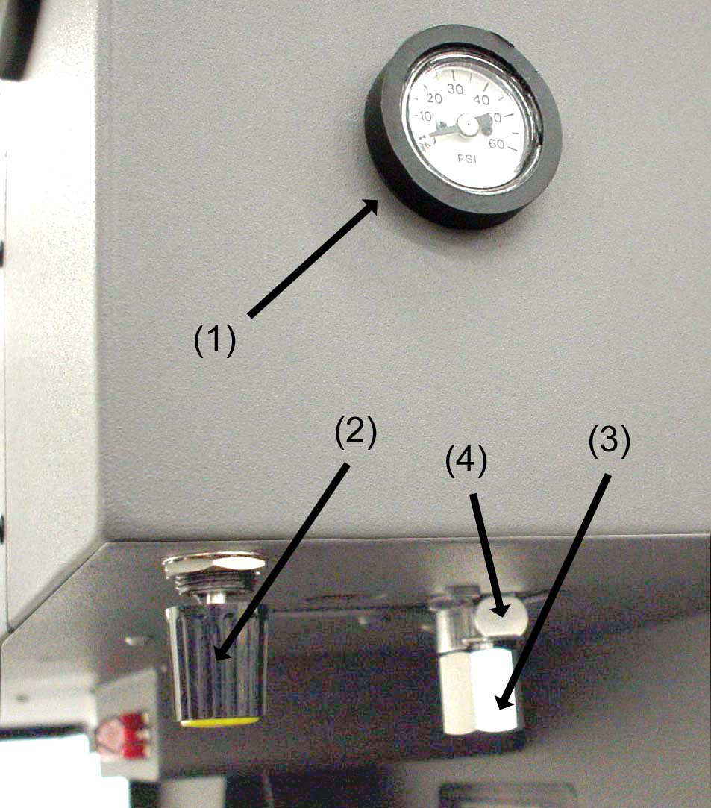
In the left rear part of the system you will find the pressure gauge (1), flow adjustment valve (2), quick release coupling (3), and release lever (4).

Push in the release lever and pull down on the quick release coupling to remove it from the machine. Attach your compressed air supply hose to this fitting (1/4 NPT threads) and use Teflon tape on the threads to prevent leaks. Re-insert the fitting until it “clicks” into place.

Attach the other end of the supply line (5) to a particulate filter (6), desiccant/dryer (7), and then to an oil-free compressed air source (8).

Computer Controlled Air Assist style
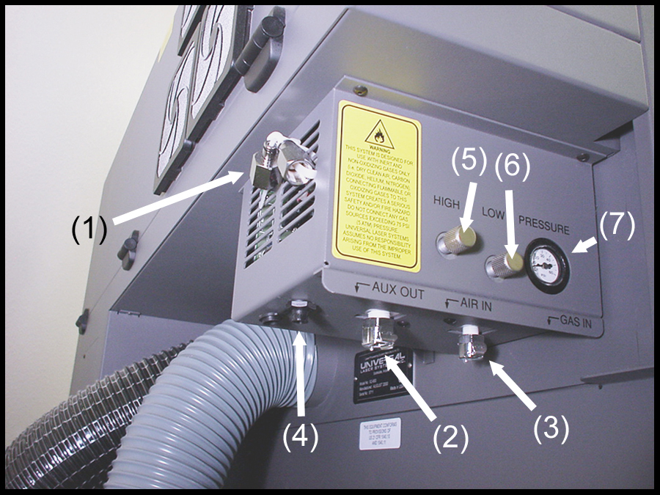
In the left rear part of the system you will find the Air Assist control box. Attached to the box, there should be two special quick release couplings secured with plastic tie wraps (1). Using a pair of scissors or wire cutters, cut off the plastic tie wraps and discard.

The AIR IN (2) fitting is where you attach the compressed air supply. The GAS IN (3) fitting is where you would attach an inert gas supply (optional). If you purchased the optional Air Compressor, you would connect the control wire to the AUX OUT (4) connector (refer to the Air Compressor instructions for more details). The HIGH (5) and LOW (6) pressure adjustment screws are used to adjust airflow to the work piece (through the cone) during operation. You can monitor the pressure by observing the pressure gauge (7) during operation.

Locate the locking ever (1) attached to both fittings. Push in the lever until it clicks. Attach the larger quick release coupling (3) (1/4 NPT threads) to your compressed air supply line (4). Use Teflon tape on the threads to prevent leaks. Push the quick release coupling (3) into the fitting (2) until it clicks into place. Attach the other end of the supply line (4) to a particulate filter (5), desiccant/dryer (6), and then to an oil-free compressed air source (7). If you have purchased the optional Air Compressor, connect the control wire (8) from the compressor (7) to the AUX IN connector (9). If using an inert gas, attach the smaller quick release coupling (11) (1/4 NPT threads) to the supply line (12) using thread sealant or Teflon tape. Push the quick release coupling (11) into the fitting (10) until it clicks into place. Attach the other end of the supply line (12) to an external pressure regulator (13) and then on to the gas tank (14).

Cone Installation and Removal (both styles)
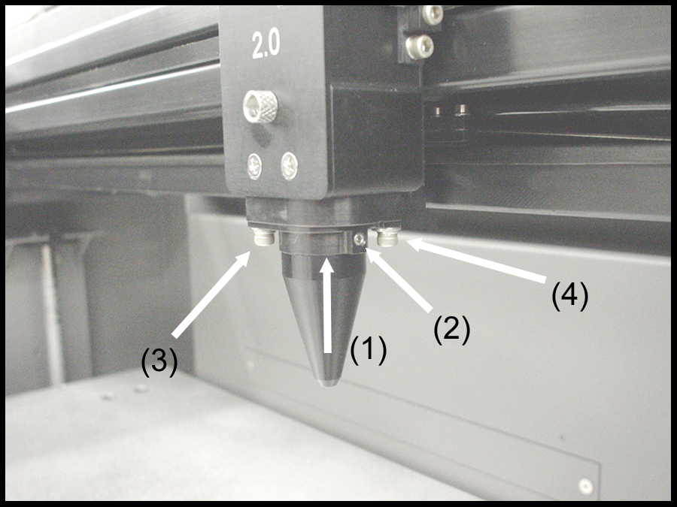
The cone must be attached to direct the air or gas supply to the laser beam's focus point. To install the cone, insert the cone (1) into the cone base completely until it bottoms out. Using a .050 inch Allen wrench, tighten the setscrew on the side of the cone base (2) until it is snug. Re-check to make sure that the cone is all the way into the base and is not tilted. To remove the cone, simply loosen the setscrew (2) and pull the cone straight down. DO NOT remove or loosen the cone base mounting screws (3) & (4) to mount or dismount the cone. These screws keep the cone base aligned with the laser beam.

DO NOT install the cone unless you plan on using Air Assist. Leaving the cone attached to the cone base and running the laser system without either air or gas flowing through the cone will destroy the focus lens within a few minutes. If you are not using Air Assist, REMOVE THE CONE. Damage of this nature is due to neglect and WILL NOT be covered under warranty.

How it Works

Standard Air Assist
The Quick Release Fitting (1) is the entry point into the rear enclosure of the laser system. From there, the air lines branch off into two paths, the optics protection path and the cone path. The optics protection path is a direct path from the quick release fitting (1) to the beam window (5), the #2 mirror (6), and the #3 mirror (7). Since this is a direct path, the amount of air pressure and flow that is coming from your compressed air source will be applied to the optics to help keep them clean from flying debris. The cone path goes through the adjustment valve (2), to the gauge (3), and then to the cone (4). The amount of air, flowing through the cone, is adjusted using the adjustment valve (2) and monitoring the pressure displayed on the gauge (3). The cone path protects the focus lens and provides a downward flow directly into the beam path at the focus point.

NOTE: Air will always be flowing through the system as long as the compressed air source is turned ON. We recommend installing a shut off valve in between your compressed air supply and the laser system.

Before you run your material, we suggest that you adjust your air and/or gas flow. To do this, you must first turn on your compressed air source so that there is flow through the system. Now, either turn the laser system ON or leave it OFF.

With the top door of the laser system open, pass a piece of paper underneath the cone and use it to note the amount of air flowing through the cone and against the paper or place your finger underneath the cone to try to feel the pressure.
As a safety precaution, you should place your finger underneath the cone ONLY when power to the system has been turned OFF. If the power is ON, you should use the paper method.

Turn the adjustment valve knob clockwise or counterclockwise until either the desired airflow or PSI reading on the gauge is achieved. Clockwise adjustments reduce flow while counterclockwise adjustments increase flow.

Computer Controlled Air Assist
The control box (1) (represented by the dotted lines) directs the compressed air source to the optics protection path and also to the cone. The optics protection path is a direct path from the entry point of the compressed air source (2) to the beam window (3), the #2 mirror (4), and #3 mirror (5). The air supply for the cone comes from either the HIGH (6) or LOW (7) solenoid valves, through the HIGH (8) or LOW (9) pressure adjustment valves, through the pressure gauge (10) and finally to the cone. The cone path protects the focus lens (11) and provides a downward flow directly into the beam path at the focus point. You choose which solenoid valve (6 or 7) to open through the laser systems printer driver. The gauge (10) will ONLY show a reading when either the HIGH (6) or LOW (7) solenoid valve is opened and air is flowing to the cone. If you choose to use an inert gas to supply the cone, the supply must go through the GAS coupling (12), through the gas solenoid valve (13) and finally to the cone. The GAS path bypasses the pressure adjustment valves and the gauge so it must be regulated externally. Only one solenoid valve (6,7, or 13) can operate at one time.

As the diagram indicates, the optics protection path is neither regulated nor solenoid valve controlled. If you are using your own compressor, the optics protection air will always be flowing regardless of whether the laser system is running or not. You must install either a manual shut off valve (not supplied) or an external electronic solenoid valve system (not supplied). If you purchased the Air Compressor option the optics protection air will turn ON and OFF as the compressor turns ON and OFF respectively.

When you press the “Start” button on the laser system, the Air Assist control box will send out a +5 VDC signal through the AUX OUT control wire, which can be used to turn ON the Air Compressor (optional) and will keep the Air Compressor ON until the file completes. This type of control saves electricity, reduces the running time of the compressor, and reduces ambient noise when the laser system is not running.

The control box also has built in pressure sensors that will detect insufficient supply pressure and will shut down the laser system. An error message, “Warning Air Pressure?” will appear on the display, indicating that there is a problem with your supply of either air or gas.

Control Panel Selections
Before you run your material, we suggest that you adjust your air and/or gas flow. To do this, you must first power ON your laser system, activate your compressed air supply, and your gas supply (if applicable). After the laser system finishes “INITIALIZING” and goes to “READY”, press the ESCAPE button once. Bring the cursor down to “PREFERENCES” and press SELECT. While the cursor is on the “OPTIONS” line, press SELECT again. Position the cursor on the “AIR ASSIST” line. Now, by pressing SELECT you can toggle that option through four choices, “AUTO”, “AIRL”, “AIRH”, and “GAS”.

AUTO
This is the default selection. It allows the control box to be automatically controlled by printer driver selections. It also serves as an “OFF” selection if you choose “OFF” in the printer driver.

AIRL
Manually activates the “LOW” valve solenoid when the “START” button, on the laser systems control panel, is pressed.

AIRH
Manually activates the “HIGH” valve solenoid when the “START” button, on the laser systems control panel, is pressed.

GAS
Manually activates the “GAS” valve solenoid when the “START” button, on the laser systems control panel, is pressed.

Adjusting Air or Gas Flow
We now need to set the flow rate through the cone. We can do this by manually activating a solenoid valve and adjusting the needle valve to achieve desired flow through the cone. With your laser system powered ON and NO files downloaded to the laser, select “AIRL” in the control panel. Press the ESCAPE button several times to get back to the “FILE DISPLAY” menu. Now press the START button. You will hear and audible “click” and the air will start flowing through the cone. With the top door of the laser system open, pass a piece of paper underneath the cone and use it to note the amount of air flowing through the cone and against the paper. Adjust the LOW pressure adjustment valve until either the desired airflow or PSI reading on the gauge is achieved. Clockwise adjustments reduce flow while counterclockwise adjustments increase flow. If you close the pressure adjustment valve too much, there might not be enough flow to keep the pressure sensor inside of the control box activated. This can trigger a “Warning Air Flow?” message to appear on the display of the laser system. If this happens, press ESCAPE, open the needle valve, and try it again. DO NOT adjust the pressure adjustment valve while there is NO air flowing as air flow through the cone is required for the gauge to display actual flow. Once desired flow is achieved, press the PAUSE button to deactivate the solenoid valve. Repeat the above procedure to set the “AIRH” (HIGH) solenoid valve pathway to the cone.

To set the GAS pressure (if applicable), repeat the above procedure again with the exception that your gas flow has to be regulated and adjusted by an external regulator mounted on the gas tank or in-line between the tank and the laser system.

Once you have set your flow rates for each pathway that you will be using, reset the laser systems control panel so that the “AIR ASSIST” option displays “AUTO”. This will allow your selections in the printer driver to activate the correct solenoid valve choices.

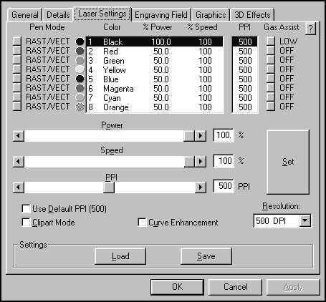
Programming the PC Printer Driver
The Air Assist option provides printer driver controlled activation and deactivation of solenoid valves that direct the flow through one of three paths with its final destination being the cone. It also has been designed to work in conjunction with the optional Air Compressor to turn it ON and OFF when the job starts and finishes, respectively. The needle valves control flow through the cone when the solenoid valves are activated. The gauge provides a visual indication of how much flow is going through the cone. You can choose between “LOW”, “HIGH”, or “GAS” valve activation setting for each one of the eight colors in the printer driver.

Power up your PC and open up or create a graphic to print to the laser system. When ready to print, go to the laser system printer driver and set all of your parameters. Next to the color choice is the button for the “Gas Assist” option. Click once on it and it turns to “LOW”. A second time and it turns to “HIGH”. A third time and it turns to “GAS” and a fourth time turns it “OFF”. Choose which pathway you desire.

Choose the rest of your parameters and download the file to the laser system. Make sure the cone is installed. Insert your material into the laser system and set the focus. Make sure that you air and gas supplies (if using) are ON. Turn on your exhaust blower and press the START button.

Air Flow Setting Guidelines (both styles)
Use as much or as little air flow necessary to produce the desired results. There are no particular settings that we can offer to you. As a rule of thumb, start with low flow and adjust upward until flaming is suppressed. Setting the flow too high can result in excessive particulate matter being blown around causing faster system contamination, which would require an increase in maintenance. It can also push the hot engraving or cutting smoke back onto the material or into the cut line and cause contamination of the surface or side edges of the material. On some scrap material play around with different flow settings to obtain the best results, then write down your settings for various materials. Remember, the intent of the Air Assist option is to suppress flaming and/or melting of the material during laser processing.

Maintenance (both styles)
- Keep you air supply and/or gas supply moisture free. Check your desiccant (water dryer) frequently. Replace desiccant when saturated or use the manufacturer’s recommendation to remove water moisture from the desiccant crystals. Water moisture may contaminate the air assist system and can cause malfunctions as well as damages to the unit.
- Clean your laser system more frequently when using Air Assist. You will need to check, and possibly clean, your optics frequently. Do not let the optics protection part of the Air Assist system lead you to a false sense of security. Since more debris gets kicked up by the downward air or gas flow through the Cone, the laser systems rails, bearings, and other motion system components will get dirtier faster than by not using the Air Assist option.
- Periodically check the cone alignment with the laser beam especially if you have replaced or adjusted the laser systems optics. You will know if your cone is not aligned if you suffer a substantial loss in laser power when laser cutting or engraving with the cone installed as opposed to the cone removed. A misaligned cone will cause the beam to make contact with the inside of the cone, possibly splitting the beam and/or reducing the power at the focus point.

Cone Alignment Check and Adjust (both styles)
- Power the laser system ON.
- Open the top door.
- Position the focus carriage in the middle of the field.
- Turn ON the red diode laser pointer.
- Place a piece of paper (1) underneath the cone and observe the position of the red beam (2) in relation to the center of the bottom of the Cone (3) and be sure to check it from the front and side.
- If the red beam is not centered, remove and reinstall the cone to see if it was due to an improperly installed cone.
- If the red beam is still not centered, check all your optics for looseness or mechanical misalignment.
- If still not centered, loosen the two base mounting screws (4) slightly (1/4 turn) and slide the base (5) around until the red diode laser comes out of the centered of the cone. Remember to check this from the front and side of the focus carriage.
- Tighten the base mounting screws (4) gently and re-check the cone’s alignment.

Air Assist Compressor
The Air Assist Compressor option is a 50 PSI @ 2.5 cfm source for oil-free, water-free, and particulate matter-free compressed air. It contains a sound insulated air compressor, water dryer (desiccant), and coalescent particulate filter. This compact and custom designed unit is a great compliment to the Air Assist System option.

Installation
- Make sure the laser system is turned off.
- Plug one end of the blue coiled hose into the compressor fitting (push in the fitting lever until it clicks before inserting) and the other end into the air inlet fitting in the laser system.
- In the computer controlled version, plug one end of the control wire to the Air Compressor and the other end into the control box.
- Plug in the compressor into a wall outlet. Please check the rating on your air compressor for the proper power requirements.
- The compressor has a three way switch, ON, OFF, and AUTO. Push the switch to the left and it will turn the compressor on all of the time. This mode is useful for non-computer controlled models. OFF is obviously off. The AUTO position allows the compressor to turn on and off only when it receives a signal from the laser system that has the computer controlled option. If you have selected the LOW, HIGH, or GAS setting in the printer driver, the Air Compressor will automatically turn ON when the file runs and OFF when the file is complete.

Maintenance
The filter and desiccant should be inspected every 8 hours of use. It may be necessary to clean out the filter and change the desiccant that is inside the dryer assembly.

To inspect the filter, you must remove it. To inspect the desiccant you can observe the color of the crystals through the slots in the metal enclosure without having to remove it. If you start to see water droplets or moisture coming through the air lines, you will definitely need to change the desiccant inside of the dryer assembly but it should never get to that point. Indication that the desiccant needs changing is the lack of blue color pigments in the desiccant. The desiccant can be regenerated. Bake it in an oven at 350 degrees F until some of the crystals turn blue again.

Removal, Cleaning, and Replacement of the Filter
- Turn the Air Compressor OFF and unplug it.
- Unscrew the cover by turning it 1/8 turn counterclockwise like you were unscrewing a jar, and pull down. The clear plastic container might still remain attached to the top. Gently pull this part straight down.
- You will see a red colored foam filter. Unscrew the filter, and wash it out with water. Make sure that it is completely dry, then reinstall.
- Empty and clean out any residue or dust that may have accumulated on the bottom of the clear plastic container.
- Install the clear plastic container into the cover and line up the tabs so that they fit one inside of the other.
- Insert the combination of the cover and the clear plastic container into the top of the assembly. Gently twist the cover 1/8 turn clockwise to lock it into place.

Removal, Cleaning, and Replacement of the Desiccant
- Turn the Air Compressor OFF and unplug it.
- Pull down on black lever and rotate metal cover 1/8 turn counterclockwise. Remove metal cover by pulling straight down.
- With a gentle and slight twisting motion, pull the clear container downward slowly. Pour out and discard old desiccant.
- Refill clear container with fresh desiccant from a sealed bag. Fill to about ¼ inch from top of container.
- Clean off rubber o-ring on the top of the container.
- Insert container up into the top.
- Install metal cover and turn 1/8 turn until lever clicks into place.

Dual Head
The Dual Head option was created to enhance productivity when engraving large quantities of the same item providing that two or more of the same item fit within the horizontal engraving area (X-axis) of your laser system. The Dual Head option can significantly reduce your overall engraving time if you divide the total processing time by the quantity of items engraved, however, there are limitations involved when using this option.

- It is not “twice as fast” than engraving with a single head. Typical productivity increases may vary from 25-75%
- In some applications, using the Dual Head option may reduce efficiency than engraving with a single head.
- There is an overall laser power loss due to additional optics ranging from 1% - 5%.
- The beam is not split EXACTLY 50/50 although it is close enough for most applications.
- Because of optical angles and the effect of passing the beam through splitting optics, the engraving field most likely WILL NOT be split EXACTLY in half. There may be a small tolerance in absolute beam positioning by as much as +/- 1/16th of an inch. In this case, you would need to compensate for the difference by adjusting the spacing between your objects in the engraving area.

How it Works
With the Dual Head installed, the special “Beam Splitter” optic inside of the Dual Head splits the laser beam in half. It reflects one half of the laser beam’s energy down through the focus lens inside the Dual Head and passes the other half of the laser beams power through the beam splitter. The laser beam goes through the beam tube and then onward through to the single heads #3 mirror where the laser beam is reflected downward through the single head’s focus lens.

By splitting the laser beam’s power in half, you effectively get approximately 50% of the power at the Dual Head and 50% at the single head. However, since the beam splitter absorbs some energy, and there are other losses involved, getting an exact 50/50 split is not possible, but the difference in most applications, is negligible.

Installation
NOTE: The example below assumes that you have also purchased the Air Assist option. If you do not have the Air Assists option, please ignore any references to the “cone(s)” or “air hose” as these two items are the only differences between the regular Dual Head and the Dual Head with Air Assist option.

- If your laser system is not ON right now, turn it ON.
- Using the menu control keys, select the “Dual Head” option in the “Options” section of the “Preferences” menu. The display will ask you to confirm your choice so respond “Yes”. It will then ask you to “Turn system OFF”, then “Wait 15 seconds”, and then “Turn system back ON”. You should do this except you should install the Dual Head BEFORE turning the system back ON.
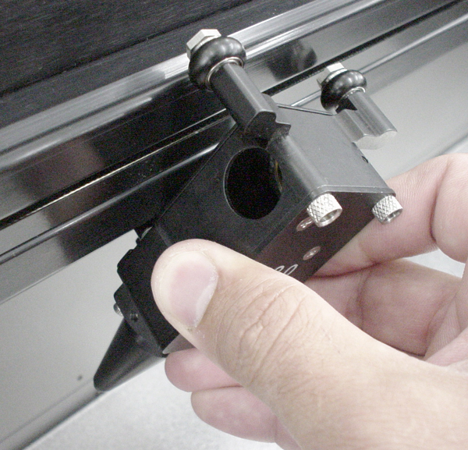
- The Dual Head will be installed to the left side of the single head. Pick up the Dual Head assembly and note that the lower X-axis bearing pivot arm should be in about the 10 o’clock position (from the backside view, and 2 o’clock from the front side. Starting with the Dual Head rotated about 30-45 degrees clockwise and tilted back towards you slightly, position the lower X-axis bearing in the lower bearing track of the X-axis rail. Gently pull up on the Dual Head while turning it counter-clockwise back to the 0 degree position and “hooking” the top two X-axis bearings into the upper bearing track of the X-axis rail.
- Verify that all three bearings are in their respective track. Gently push the carriage to the left and then back to the right. It should roll smoothly, if not, verify and/or re-install the Dual Head.

- If there is a button head screw located on the top of the Dual Head and or the single head, remove it.

- Pick up the Dual Head tube and note the “L” (Left) and “R” (Right) markings. Install the tube using the supplied thumbscrews and tighten securely.
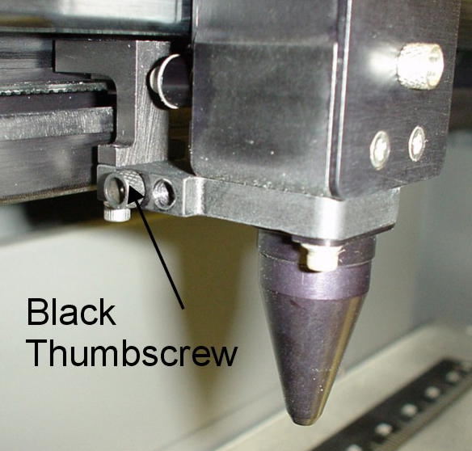
- If you have the Air Assist option, locate the 1 (one) black thumbscrew on the side of the Single Head. This thumbscrew serves two purposes, it blocks air from coming out when in Single Head operation and secures the Dual Head Air Hose when in Dual Head operation. Regardless of whether or not you will be using the Air Assist option, you should always attach the Air Hose to get it out of the way. REMINDER: If you have the Air Assist option and will not be using it, you MUST remove the air assist cone(s) before operating the system otherwise damage to the Focus Lens will occur. Refer to your Air Assist documentation on how to remove the cone(s) properly.

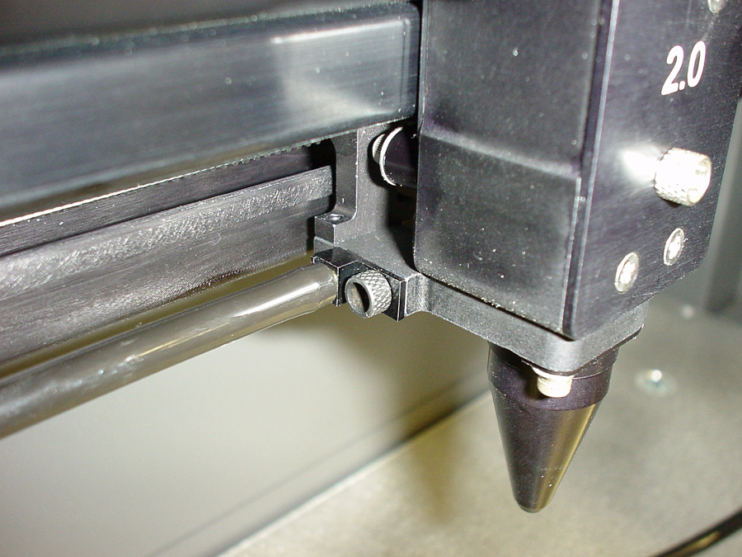

- Remove the thumbscrew and attach the end of the air hose to the single head by inserting the brass tube into the hole where the thumbscrew was removed. Attach the thumbscrew into the other threaded hole (right next to the original hole), and tighten securely.

- Installation is now complete. Turn the laser system ON and observe the control panel display. Above the “Initializing” statement you should see “(DH)” next to the model name indicating that you are now in “Dual Head” mode.
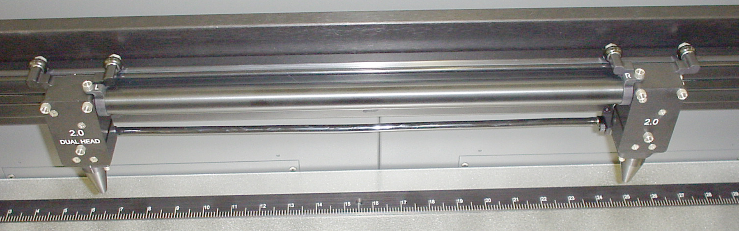

- Press the “X-Y” button to illuminate the Red Diode Pointer. You will notice that the Single Heads red dot will be brighter than the Dual Head’s red dot. This is because the Beam Splitter, inside the Dual Head does not reflect/pass visible light at a 50/50 ratio. Using the Motion Controls, position the Dual Head all the way as far as it will go into the upper left corner of the engraving area (0,0). It should be relatively close to (0,0) with +/- 1/16th of an inch. Now observe the position of the Single Head red dot. This is the (0,0) position of the second object and your reference point for placing your material.

Operation
NOTE: In the following example, we will assume that your laser engraving system is a “V Platform” that has a maximum engraving area of 24” x 18” Landscape mode.

- Turn ON your computer (if it is not ON already). Start your graphics program, create a new graphic or open an existing graphic.
- Select “Print”, choose your printer (if the laser system is not set as your default), and select “Properties” to bring up the Printer Driver settings.
- Click on the “Engraving Field” tab and then click the “Dual Head” option box. A pop-up message will appear asking you to verify your page size in your graphics software because the driver’s “Width” will now be half of what it was. Make the Height less than the Width. For example, Page Orientation = Landscape, Page Width = 12 inches, Page Height = 11 inches. NOTE: Some graphics programs do not allow your “Width” to be smaller than your “Height” when in the Landscape mode and will force you page size in your graphics program to “Portrait” mode. If this is the case and you cannot get the laser to engrave in the proper location, you might need to reduce your “Height” to something slightly smaller than your “Width” in both the Printer Driver and the graphics software program. In this example, we set the “Height” to 11 inches just to be safe.
- Adjust the page size and orientation in your graphics program to match the page size and orientation in the driver.
- Adjust your rulers in your graphics program so that the upper left corner of the page, on screen is the (0,0) position.
- Position your graphic, load your material(s) into the laser system and begin engraving.

Removal
When finished using the Dual Head, you must remove the option opposite of its installation. In the menu system, turn the “Dual Head” option OFF. “If you have the Air Assist option, remember to put the black thumbscrew back into its original hole. This will prevent the loss of air pressure in the cone of the single head.

Honeycomb Cutting Table
The purpose of the Honeycomb Cutting Table is to support the material that you are cutting off of the engraving table’s surface to minimize surface contact area. It also redirects exhaust airflow below and above the material for better smoke removal. The cutting table is installed directly on top of the engraving table. It is composed of a sheet metal box, alignment rulers, and a replaceable honeycomb style bed. The honeycomb material is reflective only in the area that contacts your material to minimize laser beam reflection. It can also be used as a vacuum table, providing you have a very strong exhaust blower, to hold down slightly warped materials or materials that tend to warp during cutting or engraving.

Installation
- Lower the table down all the way down.
- Remove the strip(s) from the exhaust plenum(s) with an Allen wrench. There is one (1) exhaust plenum on the M and V models and two (2) on the X model.
- Before installing the cutting table into the laser system, loosen the screws, without removing them, on the side of the cutting table, just enough to allow the adjustable manifold to slide in and out. Extend the adjustable manifold out as far as it can go.

- Open the front door of the laser system and carefully slide the cutting table into the laser system so that its body is squarely pushed up against the engraving table rulers on the top and the side of the table. The rulers of the cutting table should now overlap the rulers on the engraving table.
- Slide the adjustable manifold squarely up against the exhaust plenum and tighten the four (4) screws on the side of the cutting table. Be careful not to move the cutting table while tightening the screws. The objective is to have the cutting table fit snugly up against the rulers of the engraving table and the adjustable manifold fit tightly against the exhaust plenum.
- We now need to adjust the rulers of the cutting table so that they match the engraving field of the laser system. Using the focus tool method, adjust the Z Axis and focus directly onto the surface of the honeycomb.
- Loosen slightly, but do not remove, the five (5) screws that hold down the rulers.

- Activate the red diode pointer. Position the focus carriage at (0,0). With the red diode pointer still ON, slide the X-axis ruler so that its zero (0) point lines up with the red diode pointer and tighten down the left side screw.
- Now position the red diode pointer at the (32,0) position for the X series machine or (24,0) position for the M or V series machine. Adjust the right side of the X-axis ruler until it is lined up with the diode. Tighten down the right side screw of the X-axis ruler. Now tighten down the middle screw.
- Line up the right edge of the Y-axis ruler with the zero (0) line of the X-axis ruler and tighten down the top screw of the Y-axis ruler.
- Finally, position the red diode pointer at the (0,18) position for the X series machine or the (0,12) position for the M or V series machine. Align the bottom of the Y-axis ruler with the red diode pointer and tighten down the bottom screw of the Y-axis ruler. The cutting table is now ready for use.

When removing the cutting table, lower the engraving table and slide the table out of the front door. Re-install the exhaust plenum strip(s). As long as you followed the installation instructions exactly, it is designed so that you will NOT need to adjust the adjustable manifold or the X or Y-axis rulers when re-installing the cutting table.

Focus Lens Kits
There are three optional Focus Lens Kits available other than the standard 2.0”, they are the 1.5”, 2.5”, and the 4.0” kits. Included in these kits are the focus lens, #3 mirror, front plate, thumbscrews, and a focus tool.

Different lenses produce different spot sizes and have different focal ranges. For example, the 1.5” lens produces a spot size of .003” and has an effective focal range of +/- .075”. This lens can engrave very fine detail but can only be used on very flat materials. On the opposite end, the 4.0” lens has a spot size of .013” but has an effective focal range of +/- .2”. Although this lens cannot engrave very fine detail, its focal range allows you to engrave on slightly rounded or curved objects without the need for rotation. Using a baseball as an example, focus the beam halfway between the highest point and the lowest point of engraving. Since a 4.0” lens has a greater focal range than a shorter lens, you can engrave a considerable distance around the ball without having to rotate it. Attempting to engrave further around the ball will result in a loss of engraving power and a distorted image.

Refer to the following chart for spot sizes and focal ranges of the lenses available.

FOCAL LENGTH | SPOT SIZE | FOCAL RANGE
1.5 “ | .003 “ | + / - .075 “
2.0 “ | .005 “ | + / - .100 “
2.5 “ | .007 “ | + / - .125 “
4.0 “ | .013 “ | + / - .200 “

Rotary Fixture
The Rotary Fixture has been designed to engrave cylindrical objects. Two attachments come with the fixture, a cone shaped disk attached to the motorized end of the fixture and an inverted cone shaped disk attached to the adjustable end of the fixture. These attachments are used to hold wineglasses, mugs, cups, etc. To make it easier to understand, we will illustrate a step-by-step procedure to engrave an image on a glass.

NOTE: These instructions apply to many different models even if your system has a smaller or larger field size.

Installation
- Turn the laser system ON.
- Make sure AUTOFOCUS is turned OFF because the Rotary Fixture was not designed to work with AUTOFOCUS.
- Remove any materials that may be underneath the engraving table and lower the table ALL THE WAY down to the bottom or at least far enough down so that the focus carriage will clear the top of the Rotary Fixture when it is installed on the table. Now, turn the laser system OFF.

- Place the bracket on the table (1). Insert the thumbscrews and washers (2) into the screw holes but do not tighten down completely. Leave the thumbscrews loose enough so that the bracket can slide.

- Place the Rotary Fixture on a flat surface. Using an Allen wrench, attach the two socket head shoulder screws (1) to the side of the base plate.
- Place the Rotary Fixture on top of the bracket so that its pivot bolts set into the forks in the bracket. Gently push the fixture (1) flat up against the top ruler. NOW, tighten down the thumbscrews (2).

- With the power to the system still OFF, connect the 9-pin Rotary Fixture control cable to the receptacle on the laser engraving system (1).

- Before loading the glass into the fixture, measure the diameter of the glass in the area where the engraving is to be located by using a caliper or similar measuring device. Either remember this number or write it down.
- Place the open end of the glass on the right side of the Rotary Fixture. Lift the lever (1) on the adjustable end of the fixture and slide it up against the base of the glass so the glass rests firmly centered inside of the inverted cone. Push the adjustable end of the fixture (2) to the right, firmly against the bottom of the glass. Do not to apply too much pressure, especially with glass. You only need enough pressure to prevent the object from slipping on the cone while it rotates. Lower the lever on the end of the fixture to lock it in place.

- You must now focus on the glass. Power ON the laser system and wait for the display to show “READY”. Press the “Z” button on the control panel and notice that the motion system will align to the centerline of the Rotary Fixture automatically. You will also notice that the left and right arrow buttons will cause the focus carriage to move left and right respectively. This control is the same as when engraving a flat object on the table. However, the up arrow now causes the fixture to rotate the glass towards the front of the machine and the down arrow causes it to rotate towards the rear of the machine. What the Rotary Fixture actually does is remove the normal up and down Y-axis movement and replace it with a rotational movement. So instead of the system engraving down the flat page of a graphic, it takes that flat graphic and wraps it around the cylindrical object. Now, using the Focus Tool method, focus on the glass. After focusing is complete, press the “Z” button again and the arm will move back into its home position.
- If engraving a tapered object (1), the Rotary Fixture can be rotated to maintain proper focus. To do this, lift up the left end of the fixture and place some sort of spacer underneath the fixture (2) to prop it up. Slide the spacer left and right until the surface of the object is parallel (3) to the Focus Carriage. Be careful not to raise the Rotary Fixture too high (4), otherwise parts of it might interfere with the Focus Carriage (5). NOTE: If you operate the fixture in this manner, you might need to taper your graphic in your software so that it matches the taper angle of your object. Otherwise, your graphic might appear to be tapered when it is engraved.

Determining Graphic Placement
We now need to determine where we want the engraving to appear on the glass. You can use the top ruler as a visual aid in referencing the engraving area of the glass or you can use the Red Diode Laser and the X-Y coordinate system to precisely place the graphic in your graphics program. To be more precise, we will use the Red Diode Laser Pointer.

To activate the Red Diode Laser Pointer, press the X-Y button while either in the “READY”, “MAIN”, or “FILE DISPLAY” menu. The following submenu will appear:

Using the Motion Control buttons, position the Focus Carriage above the glass and observe the Red Diode Lasers position. Stop movement where you would like the top of the graphic (the right dotted line in the engraving area) to begin. Look at the coordinate display and read the “POS” “X” position. Retain this number in memory or write it down. Ignore the “Y” position. Now, position the red dot at the lowest point (the left dotted line in the engraving area) on the glass where you would like the engraving to end. Remember this “POS” “X” coordinate or write it down.

In this example our upper limit is about 20500X and the lower limit is 19000X. This translates to 20.5 inches and 19.0 inches respectively because the coordinates are in 1/1000 inch units.

We have now set up the glass to be engraved. Close all doors of the laser system, go to your computer, and open your graphics software.

Printer Driver Settings
With your graphics software open, proceed immediately to “Printer Setup” and open the printer driver. In the printer driver, click on the “Engraving Field” tab, is set to page orientation to ”Landscape” and the size set to the maximum field size of the laser system. In this example, we will set it to 24 x 12 inches. Then, click on the “Rotary Installed” selection box and type in the diameter of the glass that was measured.

Notice that while typing in the diameter, the size of the height dimension changes automatically. Remember or write down this new page size. In this example, the diameter of the glass is 3.075 inches. After typing in this number, observe that the new page height is now 9.66 inches. Click on “OK” and go back to the graphics software’s page setup and change it to EXACTLY match the new page size that the Printer Driver established when the diameter of the object was typed in.

This new vertical page size is now the actual circumference of the object that is going to be engraved. From the top of the page (on screen) to the bottom represents one complete revolution of the Rotary Fixture. For example, if engraving a glass that has a diameter of 3.075 inches (78.1 mm), the driver calculates that the circumference of the glass (and vertical page size) is 9.66 inches (245.4 mm).

Position the graphic, on screen, so that it will fit vertically within the new vertical page height (circumference) and horizontally within the upper and lower engraving limits that we earlier determined with the Red Diode Laser Pointer. If the graphic does not fit within the vertical page size limits, the portion that is outside the page limit will not engrave. Remember, the new page size that the driver calculates from the diameter of the glass is it’s actual circumference. From the top of the page down to the bottom is one complete revolution of the glass. Since the Rotary Fixture will not turn more than 360 degrees, make sure that the graphic lies between the page limits.

You are now ready to print to the laser system. Make sure that you system is ready to engrave and then begin the process.

Rotary Fixture Removal
Turn the laser system OFF. Unplug the fixture’s power cable. Remove fixture from laser system by lifting it off the bracket. If you plan on using your fixture daily, you might want to leave the bracket attached to the table so that you can easily load and unload the fixture. If you seldom use the fixture, you might want to remove the bracket from the engraving table because the bracket may interfere with using “Autofocus”. If you use “Autofocus” and leave the bracket attached to the table, the thinnest piece of material that you can “Autofocus” on would be the thickness of the bracket because the “Autofocus” sensor can only detect materials taller than the bracket unless the bracket is removed. If you do not use “Autofocus”, then you can leave the bracket attached to the table, it is your choice.

