DUAL HEAD
V and X Platform

Installation and Operation
Instructions

01/01/00

Before using this option, it is strongly recommended that you completely understand how to operate the laser system in the normal “Single Head” mode of operation. Attempting to use this option without being completely familiar and comfortable with the laser system when operating it normally may result in costly down time, frustration, and unnecessary telephone calls to our Service Department.

The Dual Head option was created to enhance productivity when engraving large quantities of the same item providing that two or more of the same item fit within the horizontal engraving area (X-axis) of your laser system.

The Dual Head option can significantly reduce your overall engraving time if you divide the total processing time by the quantity of items engraved, however, there are limitations involved when using this option.

- It is not “twice as fast” than engraving with a single head. Typical productivity increases may vary from 25-75%
- In some applications, using the Dual Head option may reduce efficiency than engraving with a single head.
- There is an overall laser power loss due to additional optics ranging from 1% - 5%.
- The beam is not split EXACTLY 50/50 although it is close enough for most applications.
- Because of optical angles and the effect of passing the beam through splitting optics, the engraving field most likely WILL NOT be split EXACTLY in half. There may be a small tolerance in absolute beam positioning by as much as +/- 1/16th of an inch. In this case, you would need to compensate for the difference by adjusting the spacing between your objects in the engraving area.

How it Works

With the Dual Head installed, the special “Beam Splitter” optic inside of the Dual Head splits the laser Beam in half. It reflects one half of the laser beam’s energy down through the focus lens inside the Dual Head and passes the other half of the laser beams power through the Beam Splitter. The laser beam goes through the Beam Tube and then onward through to the Single Heads #3 mirror where the laser beam is reflected downward through the Single Heads Focus Lens.

By splitting the laser beam’s power in half, you effectively get approximately 50% of the power at the Dual Head and 50% at the Single Head. However, since the Beam Splitter absorbs some energy, and there are other losses involved, getting an exact 50/50 split is not possible, but the difference in most applications, is negligible.

Installation

NOTE: The example below assumes that you have also purchased the Air Assist option. If you do not have the Air Assists option, please ignore any references to the “Cone(s)” or “Air Hose” as these two items are the only differences between the regular Dual Head and the Dual Head with Air Assist option.

- If your laser system is not ON right now, turn it ON.
- Using the menu control keys, select the “Dual Head” option in the “Options” section of the “Preferences” menu. The display will ask you to confirm your choice so respond “Yes”. It will then ask you to “Turn system OFF”, then “Wait 15 seconds”, and then “Turn system back ON”. You should do this except you should install the Dual Head BEFORE turning the system back ON.
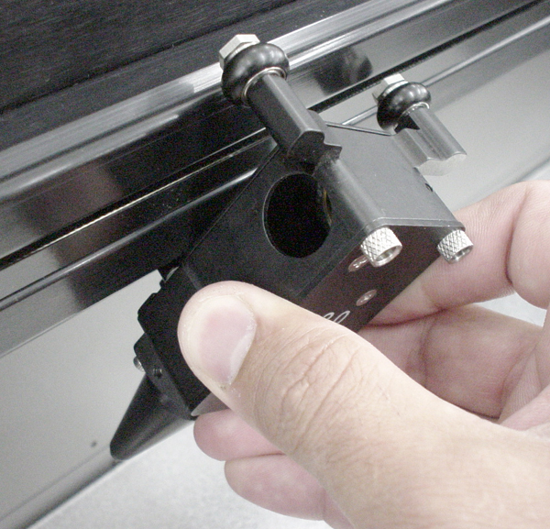
- The Dual Head will be installed to the left side of the Single Head. Pick up the Dual Head assembly and note that the lower X-axis bearing pivot arm should be in about the 10 o’clock position (from the backside view, and 2 o’clock from the front side. Starting with the Dual Head rotated about 30-45 degrees clockwise and tilted back towards you slightly, position the lower X-axis bearing in the lower bearing track of the X-axis rail. Gently pull up on the Dual Head while turning it counter-clockwise back to the 0 degree position and “hooking” the top two X-axis bearings into the upper bearing track of the X-axis rail.
- Verify that all three bearings are in their respective track. Gently push the carriage to the left and then back to the right. It should roll smoothly, if not, verify and/or re-install the Dual Head.
- If there are any button head screws located on the top of the Dual Head and or the Single Head, remove them now.
- Pick up the Dual Head Tube and note the “L” (Left) and “R” (Right) markings. Install the tube using the supplied thumbscrews and tighten securely.

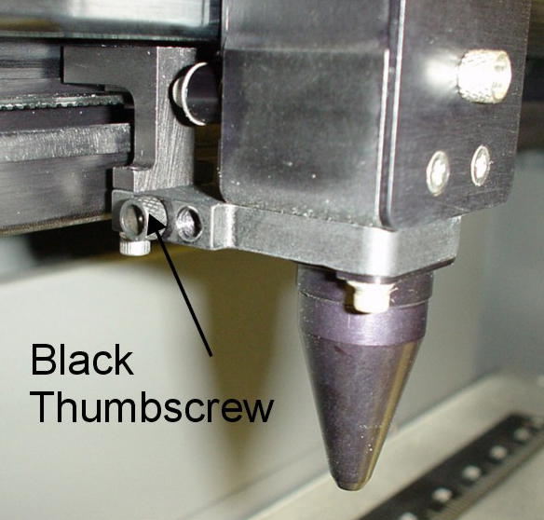
- If you have the Air Assist option, locate the 1 (one) black thumbscrew on the side of the Single Head. This thumbscrew serves two purposes, it blocks air from coming out when in Single Head operation and secures the Dual Head Air Hose when in Dual Head operation. Regardless of whether or not you will be using the Air Assist option, you should always attach the Air Hose to get it out of the way. REMINDER: If you have the Air Assist option and will not be using it, you MUST remove the Air Assist Cone(s) before operating the system otherwise damage to the Focus Lens will occur. Refer to your Air Assist documentation on how to remove the Cone(s) properly.
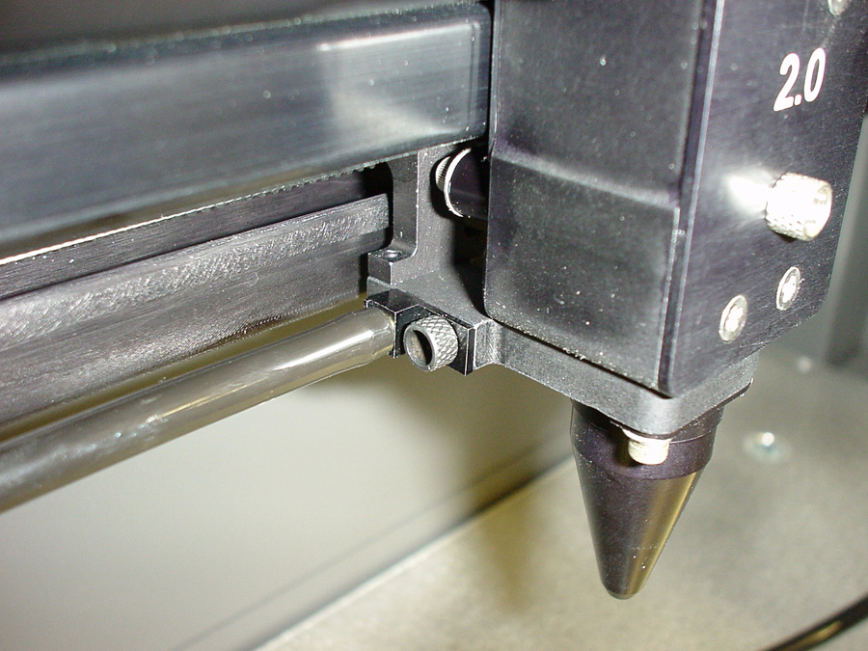
- Remove the thumbscrew and attach the end of the Air Assist hose to the Single head by inserting the brass tube into the hole where the thumbscrew was removed from. Attach the thumbscrew into the other threaded hole (right next to the original hole), and tighten securely.
- Installation is now complete. Turn the laser system ON and observe the control panel display. Above the “Initializing” statement you should see “(DH)” next to the model name indicating that you are now in “Dual Head” mode.

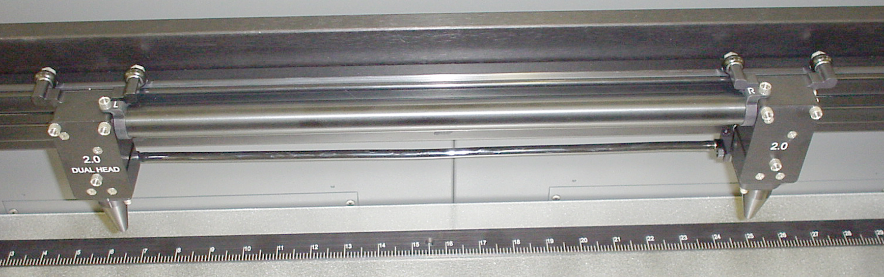

- Press the “X-Y” button to illuminate the Red Diode Pointer. You will notice that the Single Heads red dot will be brighter than the Dual Head’s red dot. This is because the Beam Splitter, inside the Dual Head does not reflect/pass visible light at a 50/50 ratio. Using the Motion Controls, position the Dual Head all the way as far as it will go into the upper left corner of the engraving area (0,0). It should be relatively close to (0,0) with +/- 1/16th of an inch. Now observe the position of the Single Head red dot. This is the (0,0) position of the second object and your reference point for placing your material.

Operation

NOTE: In the following example, we will assume that your laser engraving system is a “V Platform” that has a maximum engraving area of 24” x 18” Landscape mode.

- Turn ON your computer (if it is not ON already). Start your graphics program, create a new graphic or open an existing graphic.
- Select “Print”, choose your printer (if the laser system is not set as your default), and select “Properties” to bring up the Printer Driver settings.
- Click on the “Engraving Field” tab and then click the “Dual Head” option box. A pop-up message will appear asking you to verify your page size in your graphics software because the driver’s “Width” will now be half of what it was. Make the Height less than the Width. For example, Page Orientation = Landscape, Page Width = 12 inches, Page Height = 11 inches. NOTE: Some graphics programs do not allow your “Width” to be smaller than your “Height” when in the Landscape mode and will force you page size in your graphics program to “Portrait” mode. If this is the case and you cannot get the laser to engrave in the proper location, you might need to reduce your “Height” to something slightly smaller than your “Width” in both the Printer Driver and the graphics software program. In this example, we set the “Height” to 11 inches just to be safe.
- Adjust the page size and orientation in your graphics program to match the page size and orientation in the driver.
- Adjust your rulers in your graphics program so that the upper left corner of the page, on screen is the (0,0) position.
- Position your graphic, load your material(s) into the laser system and begin engraving.

Removal

When finished using the Dual Head, you must remove the option opposite of its installation. In the menu system, turn the “Dual Head” option OFF. “If you have the Air Assist option, remember to put the black thumbscrew back into its original hole. This will prevent the loss of air pressure in the Cone of the Single Head.

If you need assistance, please contact our Service Department.

Universal Laser Systems, Inc.
Technical Support/Parts Department
16008 North 81st Street
Scottsdale, AZ 85260
Phone: 480-609-0297
Fax: 480-609-1203
Email: service@ulsinc.com
M-F 7am – 5pm Arizona Time

