XL ARM REPLACEMENT
March 22, 2007
Universal Laser Systems

This document is for the replacement of the arm of the XL engraver. The document covering arm square and beam alignment must be sent with this document.

**Turn off the engraver and unplug the connector before proceeding**

1) Open the engravers back, front, and top doors to expose the side panel screws.
The panel screws are on the left and right sides of the engraver. Gently lower the panels all the way down until they touch the legs of the engraver.

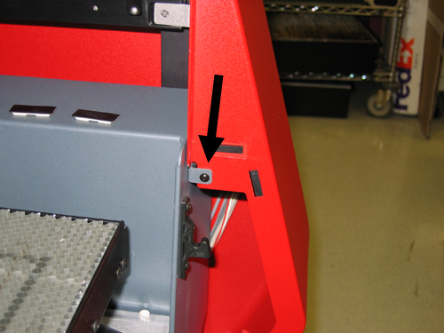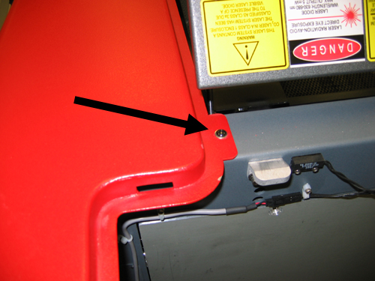

2) With the left and right side covers open, start on the right side.
Remove the motor electrical connections from the circuit board that is visible off the right side of the arm.
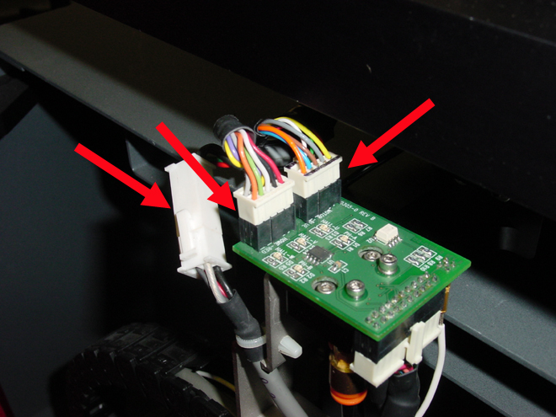

3) Remove the motor cover from the arm.

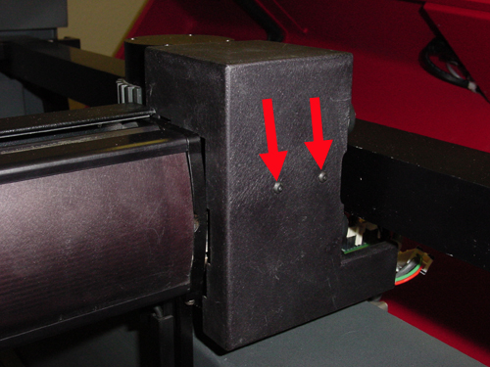

4) Remove the screws from the left side of the arm; support the arm with a block of foam or similar material.

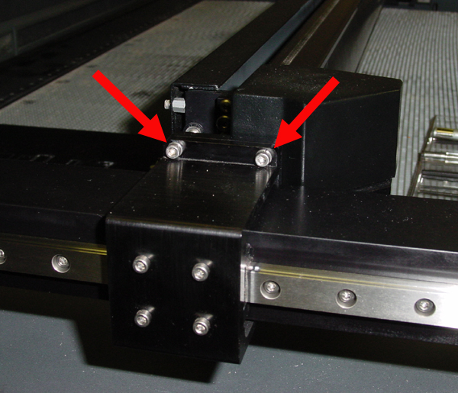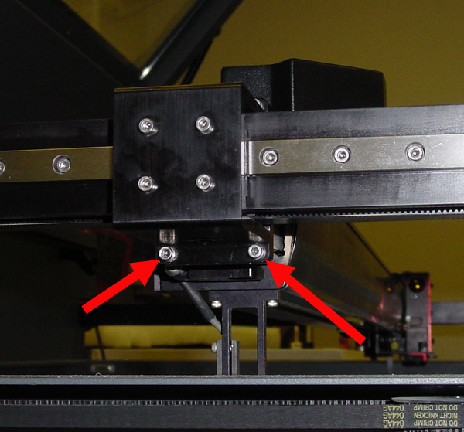

5) Remove the air connections from under the motor. The orange collar on the air connection has to be pushed in while the tubing is pulled out.

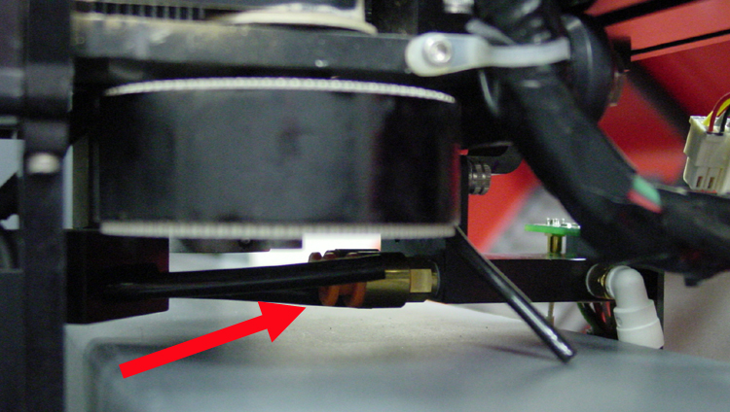

6) Look under the right Y rail to locate the screws that hold the Y axis wire tray and Y axis belt grip from the arm. In the photo below, the red arrows point to the wire tray screws and the green arrows point to the belt grip.

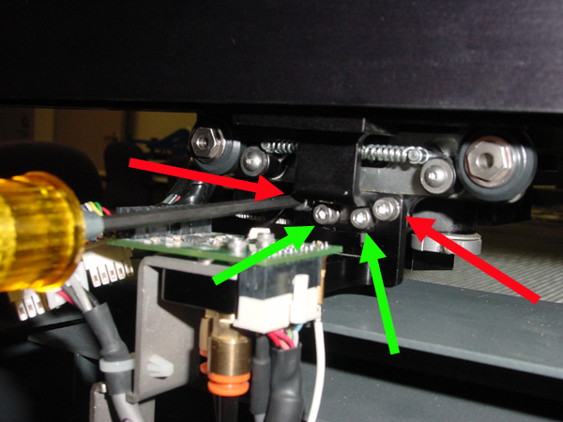

7) Remove the arm from the engraver by pushing the arm towards the left side of the arm and push or pull the right side of the arm to allow the bearings to slip off of the Y rail.

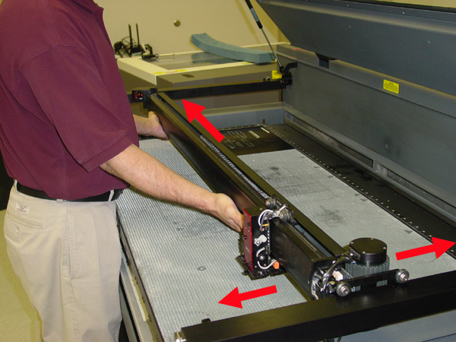

8) Installation of the new arm is in reverse of removal. Airline installation will require the use of a pair of forceps that have had the jaws wrapped with electrical tape. This will allow the hose to be gripped while installation, but not rupture the hose.

