
Section 1

Safety

Description of Appropriate Use
This device is designed for laser cutting and engraving of the materials listed in this manual, in a laboratory, workshop, or light duty manufacturing environment. Materials to be processed must fit completely inside the system for proper operation.

Notice: This device is not designed, tested, intended or authorized for use in any medical applications, surgical applications, medical device manufacturing, or any similar procedure or process requiring approval, testing, or certification by the United States Food and Drug Administration or other similar governmental entities. Please see the Notice herein for further information regarding such uses.

General Safety
Use of the equipment in a manner other than what is described in this manual can result in injury to yourself, others, or may cause severe damage to the equipment and your facility. Failure to follow the operational requirements and safety guidelines, listed in this manual, may increase this risk.

- Exposure to the laser beam may cause physical burns and can cause severe eye damage. Proper use and care of this system are essential to safe operation.

- Never operate the laser system without constant supervision of the cutting and engraving process. Exposure to the laser beam may cause ignition of combustible materials and start a fire. A properly maintained fire extinguisher should be kept on hand at all times.

- A properly configured, installed, maintained, and operating particulate/fume exhaust system is mandatory when operating the laser system. Fumes and smoke from the engraving process must be extracted from the laser system and exhausted outside.

- Some materials, when engraved or cut with a laser, can produce toxic and caustic fumes. We suggest that you obtain the Material Safety Data Sheet (MSDS) from the materials manufacturer. The MSDS discloses all of the hazards when handling or processing that material. DISCONTINUE processing any material that shows signs of chemical deterioration of the laser system such as rust, metal etching or pitting, peeling paint, etc. Damage to the laser system from caustic materials is NOT covered under warranty.

- Care should be taken when moving or lifting this device. Obtain assistance from 1 or 2 additional people when lifting or carrying (secure motion system and doors). Severe bodily injury may occur if improper lifting techniques are applied or the system is dropped.

- Dangerous voltages are present within the electronics and laser enclosures of this system. Although access to these areas is not necessary during normal use, if it becomes necessary to open one of these enclosures for service reasons please remember to disconnect the power cord from your electrical supply.

- This device is specifically designed to comply with CDRH performance requirements under 21 CFR 1040.10 and 1040.11. CDRH is the Center for the Devices of Radiological Health division of the Food and Drug Administration (FDA) in the USA. It also complies with CE (European Community) safety regulations. No guarantees of suitability or safety are provided for any use other than those specified by Universal Laser Systems, Inc.

Laser Safety
The device contains a sealed carbon dioxide (CO2) laser in a Class I enclosure that produces intense invisible and visible laser radiation at a wavelength of 10.6 microns in the infrared spectrum. For your protection, this enclosure is designed to completely contain the CO2 laser beam. Improper use of controls and adjustments, or performance of procedures other than those specified, may invalidate the safety of this system.

- The intense light that appears during the engraving or cutting process is the product of material combustion or vaporization. DO NOT STARE AT THE BRIGHT LIGHT OR VIEW DIRECTLY WITH OPTICAL INSTRUMENTS.

- This device may contain a visible Red Dot Pointer (Class IIIa). DO NOT STARE AT THE RED LIGHT OR VIEW DIRECTLY WITH OPTICAL INSTRUMENTS.

- The user door(s) are safety interlocked and will disable the CO2 laser beam from firing when the user door(s) are opened. The Red Dot Pointer is NOT safety interlocked and can be activated with the door(s) either open or closed.

- Do not operate any system that has had its safety features modified, disabled, or removed as this can expose your eyes and skin to invisible and visible CO2 laser radiation which can cause permanent blindness and/or severe burns to your skin.

Safety Labels
CDRH and CE regulations require that all laser manufacturers affix warning labels in specific locations throughout the equipment. The following warning labels are placed on the laser system for your safety. DO NOT remove them for any reason. If the labels become damaged or have been removed for any reason, DO NOT OPERATE the laser system and immediately contact Universal Laser Systems, Inc. for a free replacement. Labels are NOT to scale.

221-0004-0 | 221-0007-0 | 221-0012-0

221-0013-0 | 221-0015-0 | 221-0016-0

221-0017-0 | 221-0018-0 | 221-0034-0

 | Located inside electrical enclosure next to main ground lug
221-0020-0 | 221-0021-0 | 221-0024-0

221-0031-0 | 221-0033-0 | 221-0081-0

221-0037-0 | 221-0065-0

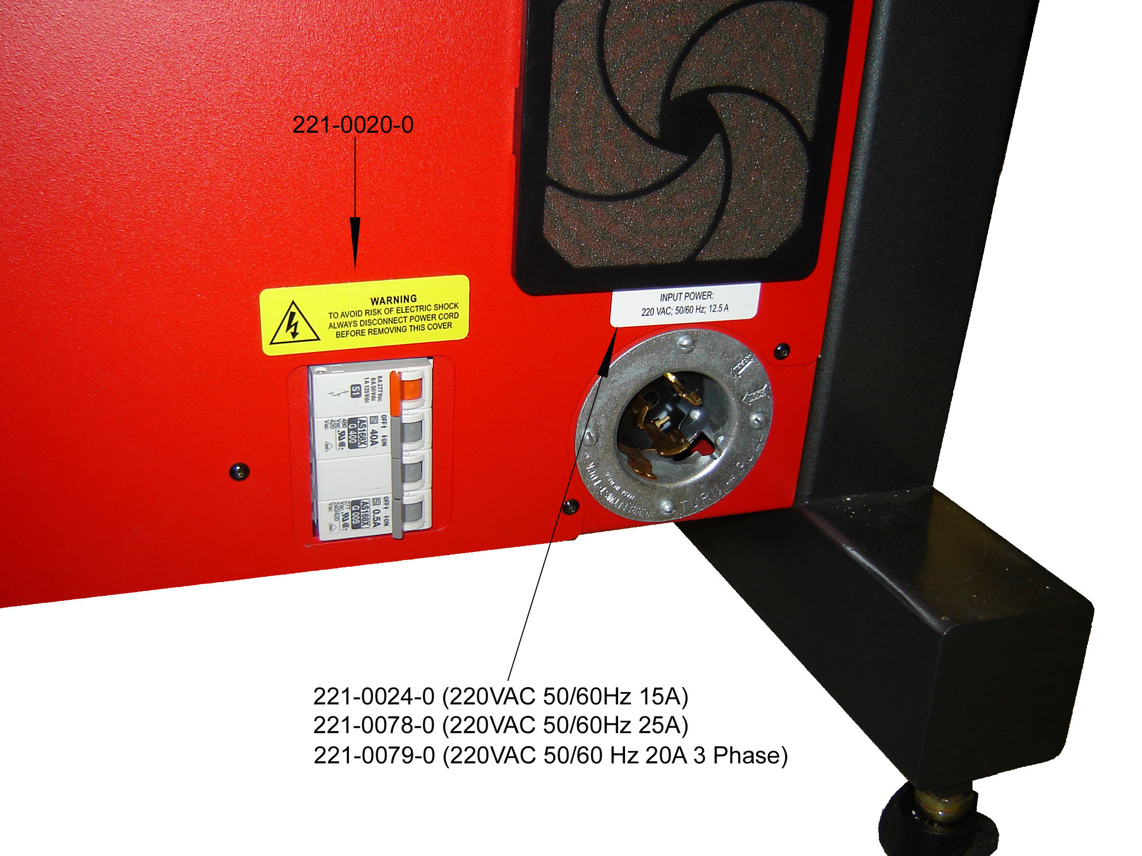
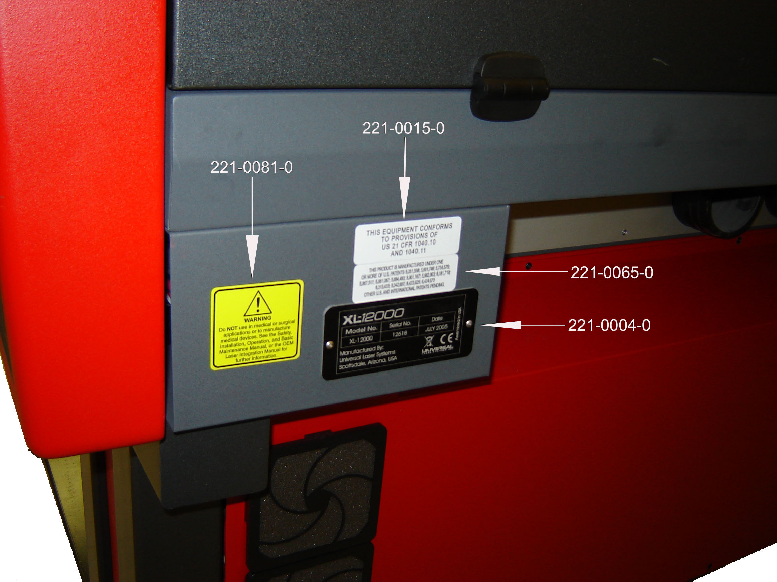

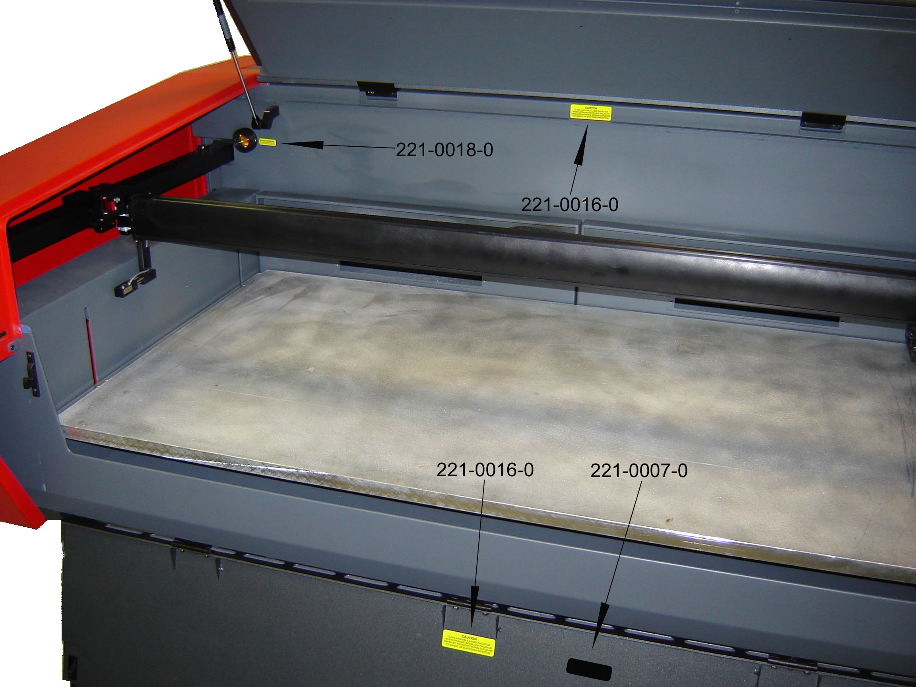
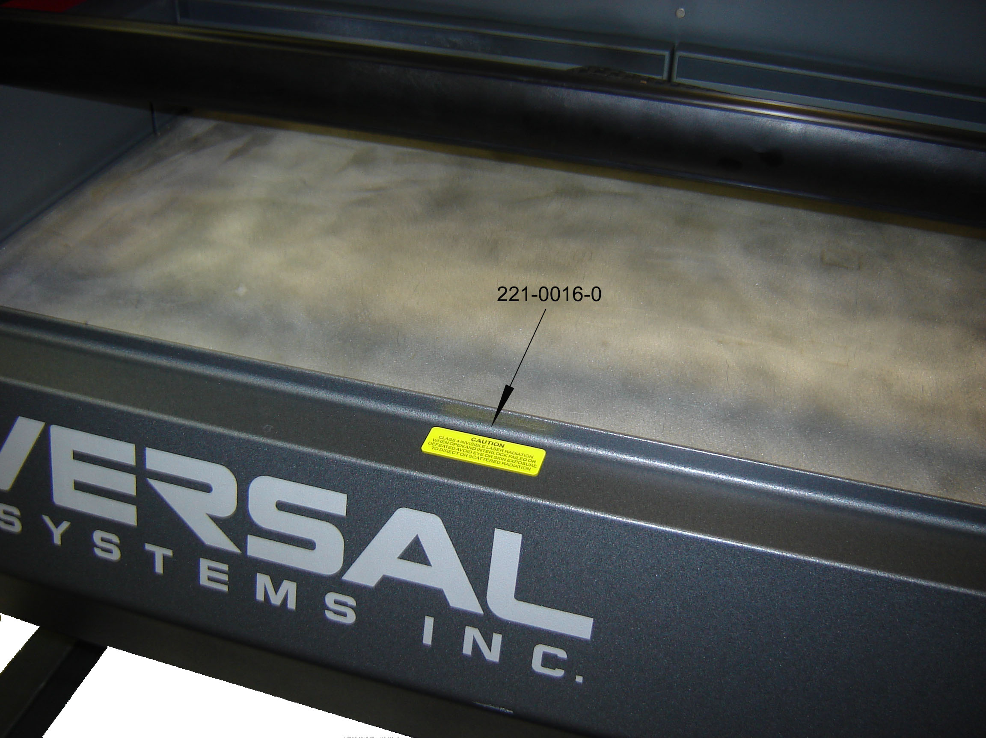
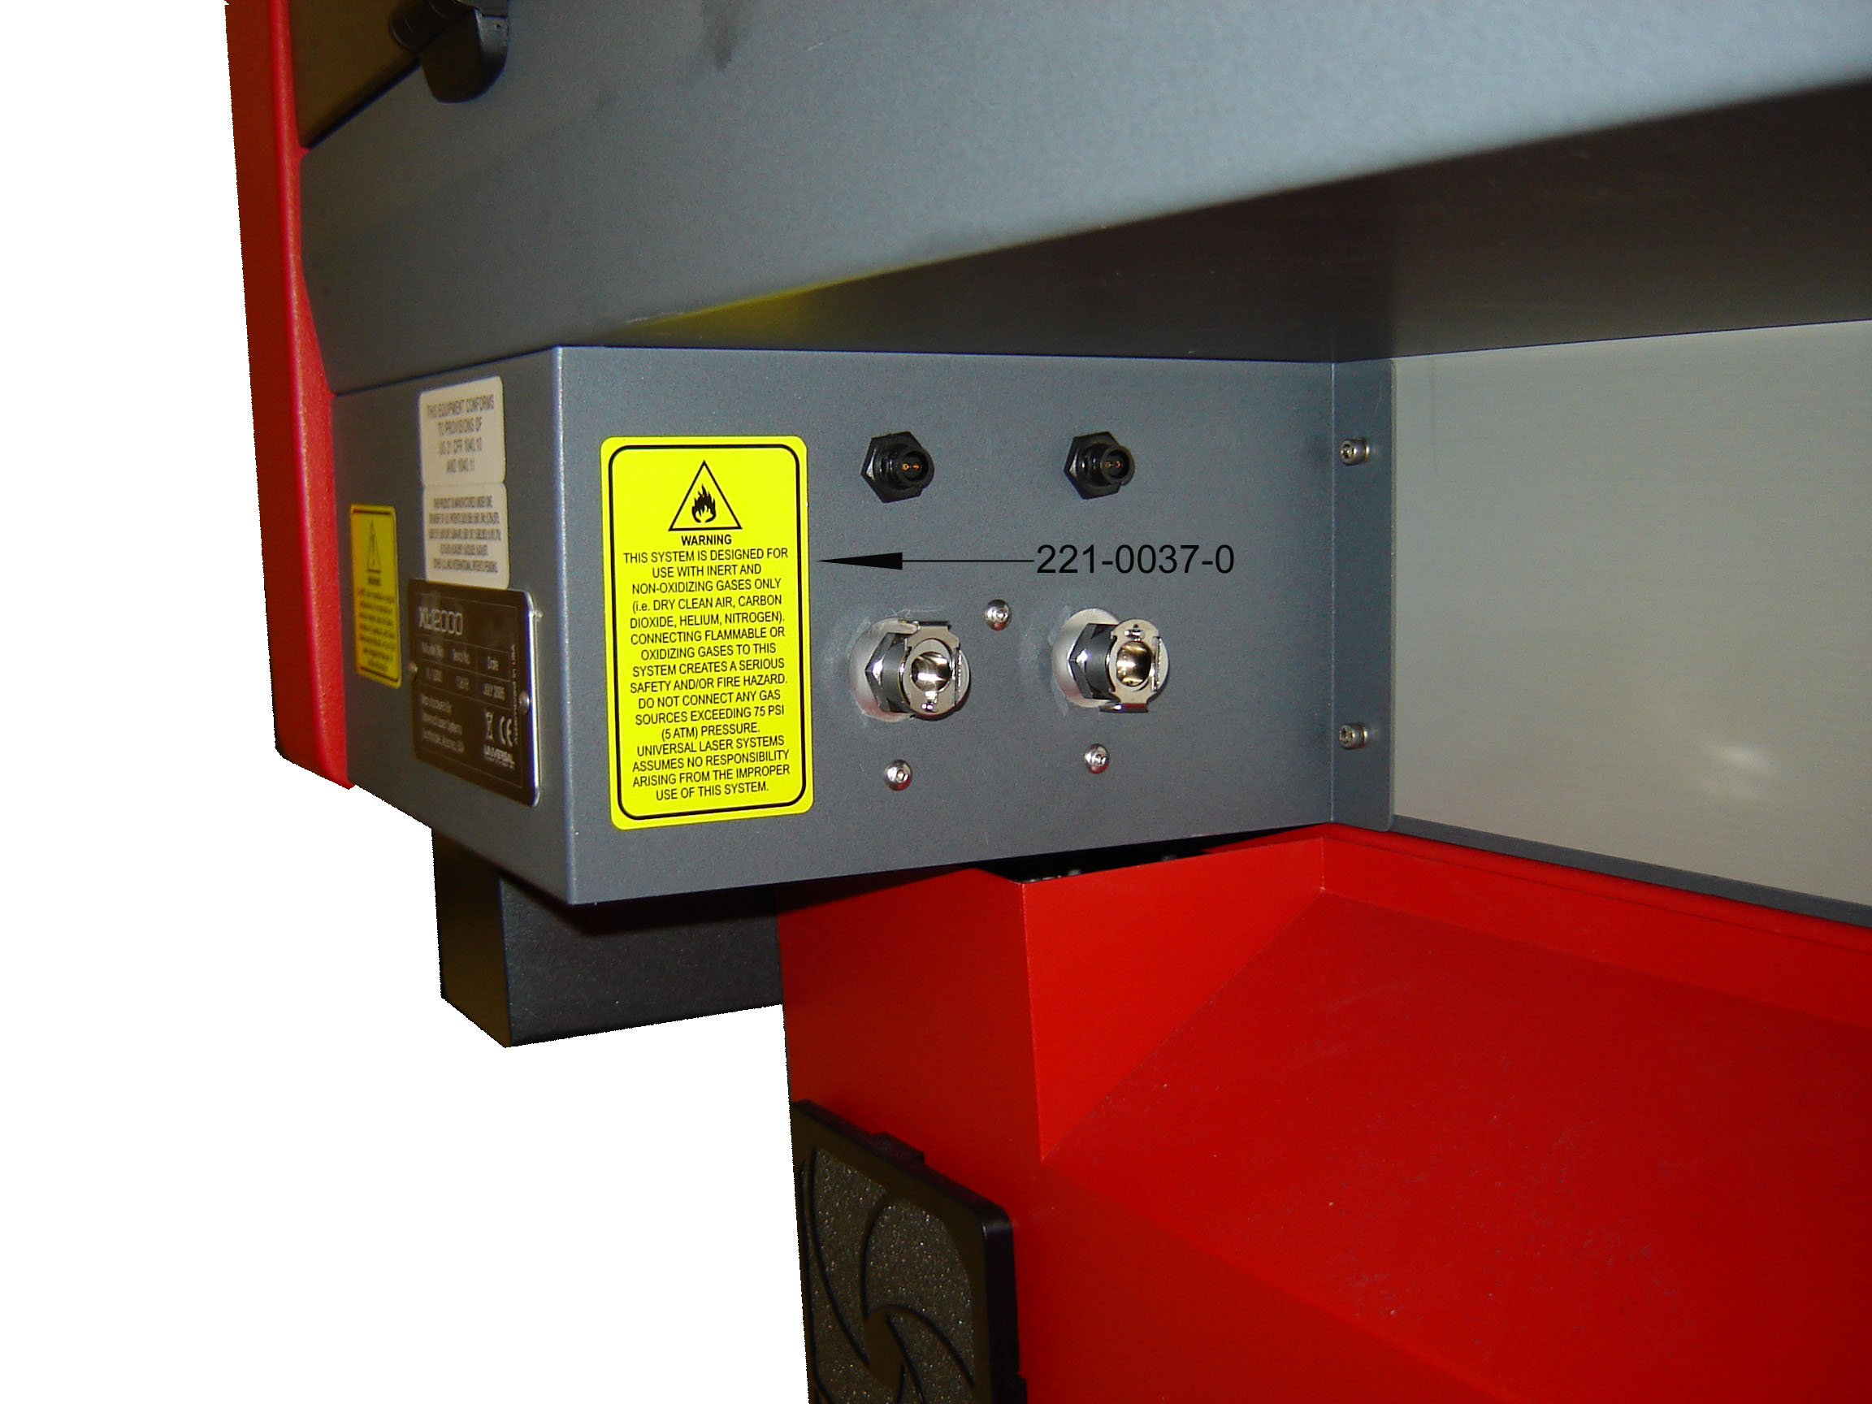

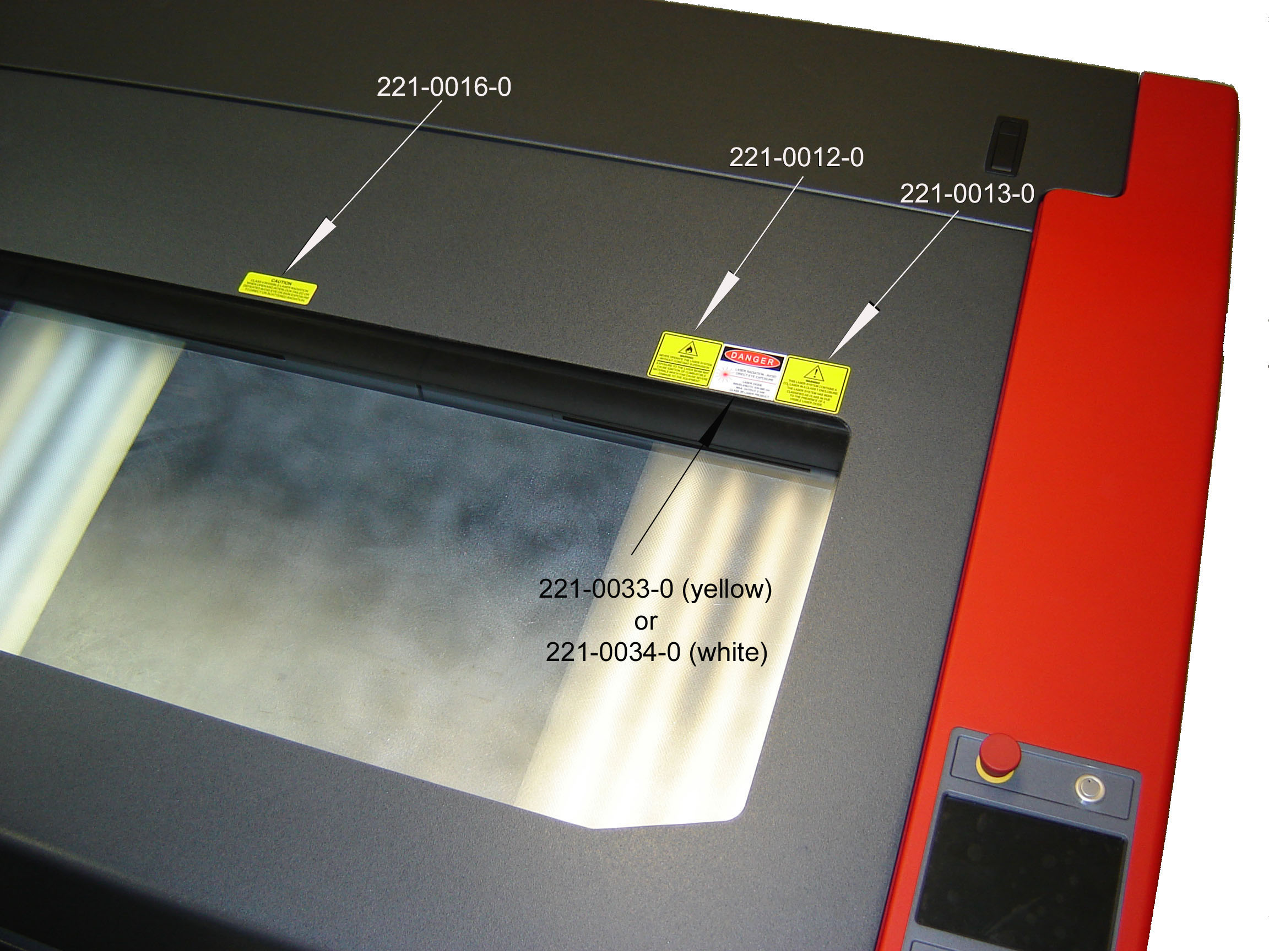

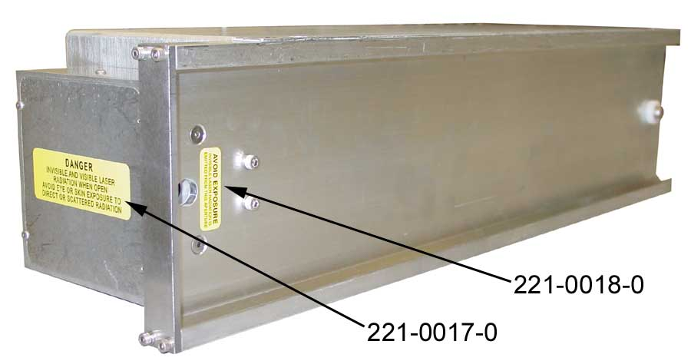
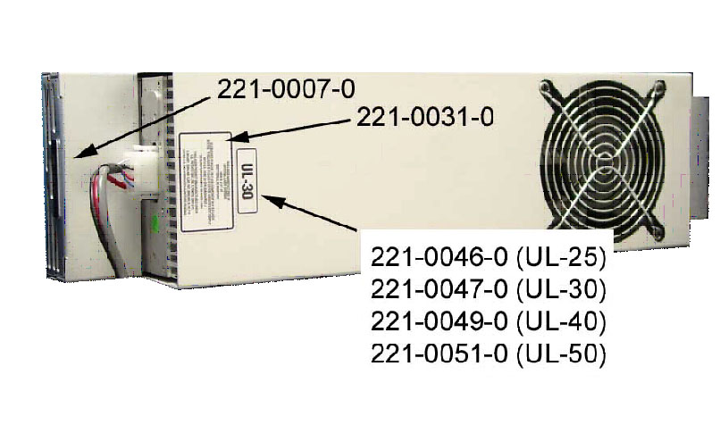

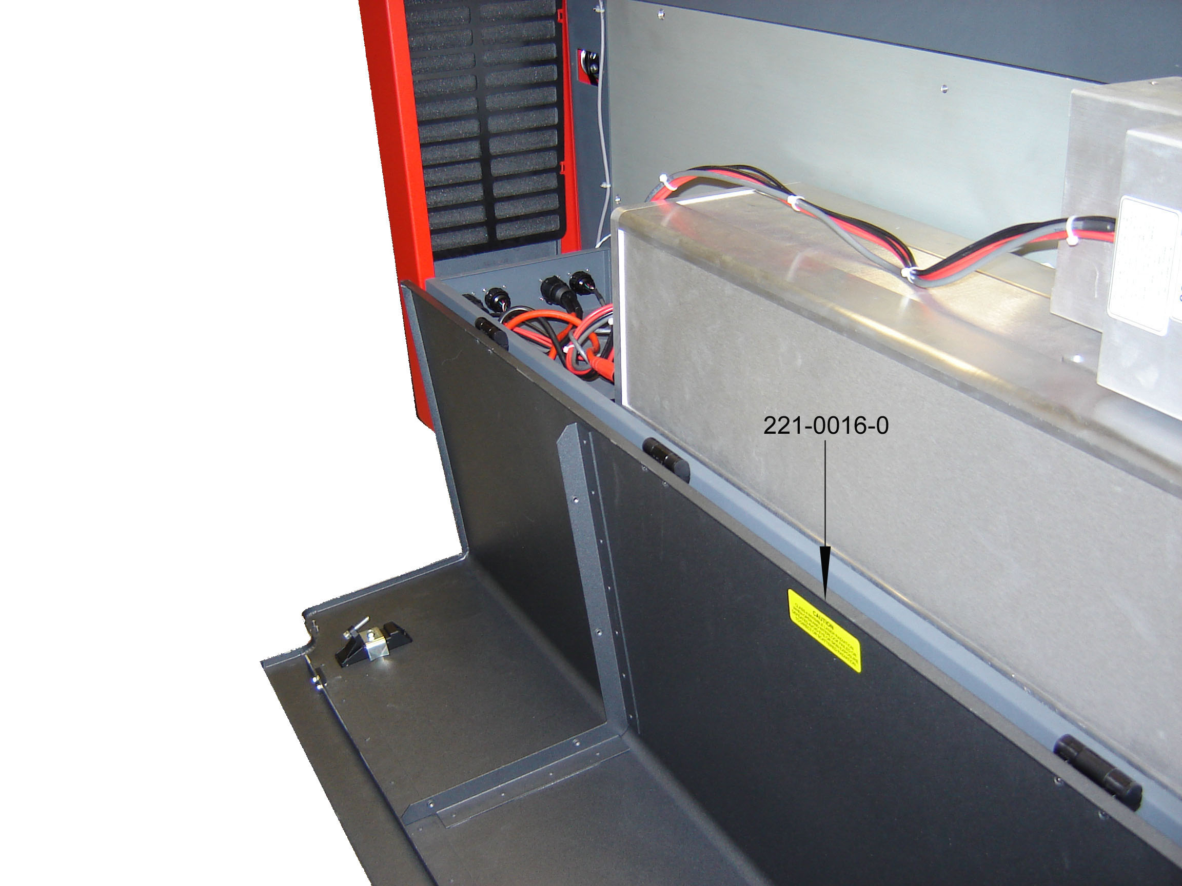
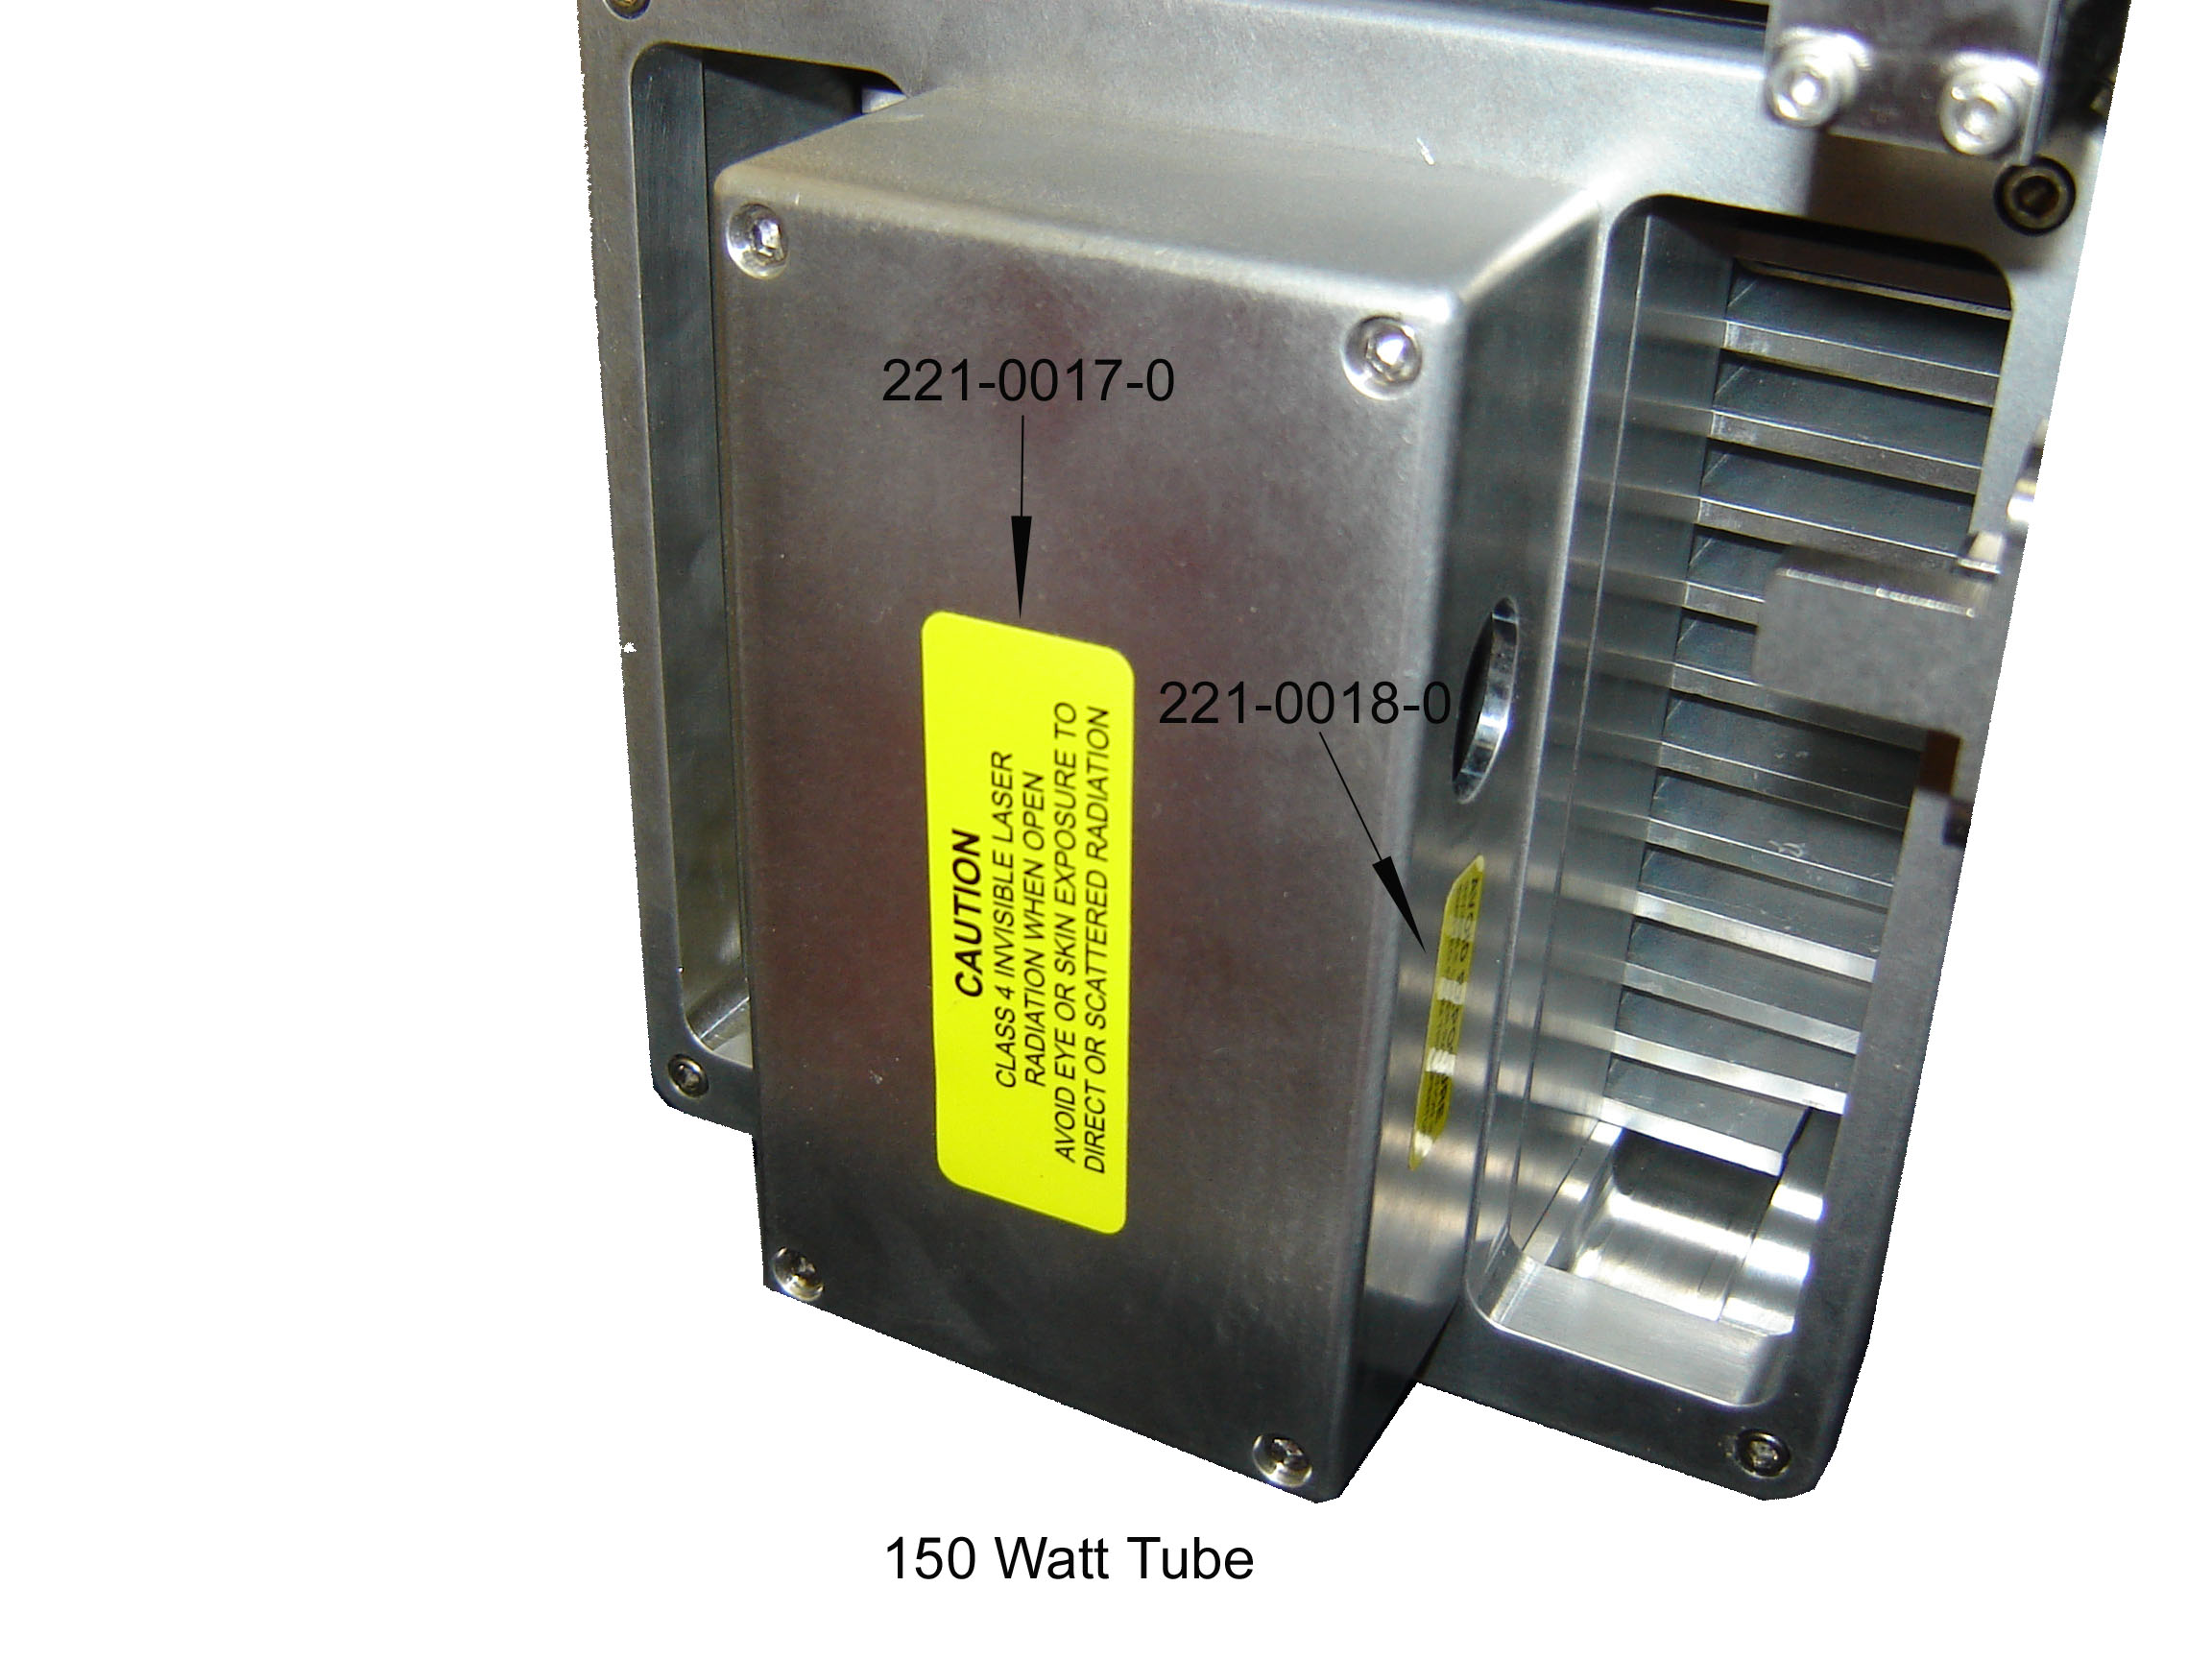
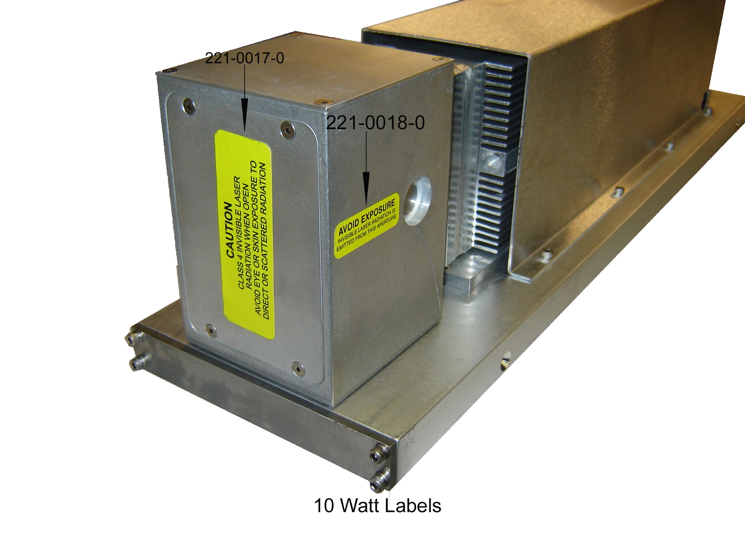

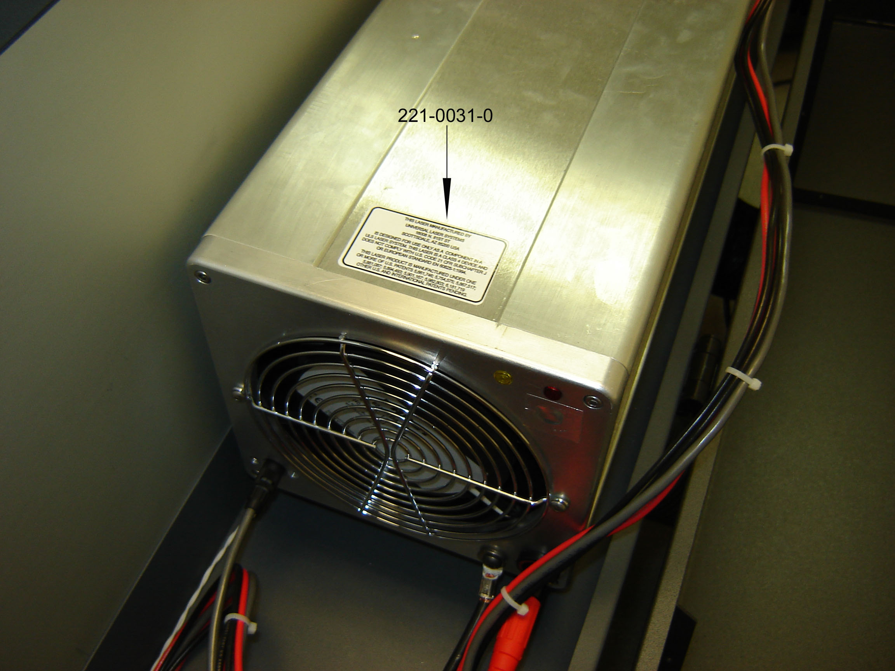

EU Compliance (CE)

Product Identification: XL9200/XL12000
Laser Engraving and Cutting Systems

Manufacturer: Universal Laser Systems, Inc.
16008 N. 81st St.
Scottsdale, AZ 85260
Phone: (480) 483-1214 Fax: (480) 483-5620
USA

This equipment Is manufactured in conformity with the following directives:

89/336/EEC (EMC Directive)
73/23/EEC (Low Voltage Directive)
98/37/EEC (Machinery Directive)

based on the standards listed.

Standards Used:

Safety:
EN 60950: 2002
EN 60825: 2001 (Class 3R)

EMC:
EN 55022: 2003 (Class A)
EN 50082-1: 1998
EN 61000-3-2: 2001 (class A)
EN 61000-3-3: 2002
EN 61000-4-2: 2001 (6kV CD, 8kV AD)
EN 61000-4-3: 2003 (3 V/m)
EN 61000-4-4: 2002 (2 kV power line, 0.5 kV signal line)
EN 61000-4-5: 2001 (class 2)

Note: This is not a declaration of conformity. The importer of this equipment supplies the declaration of conformity.

Warning - This is a Class A product. In a domestic environment, this product may cause radio interference in which case the user may be required to take adequate measures.

FCC Compliance

This ULS laser system has been tested and found to comply with Federal Communication Commission (FCC) directives regarding Electromagnetic Compatibility (EMC). In accordance with these directives ULS is required to provide the following information to its customers.

FCC Compliance Statement and Warnings

This device complied with FCC Rules Part 15. Operation is subject to the following two conditions:

- This device may not cause harmful interference, and

- This device must accept any interference received, including interference that may cause undesired operation.

This equipment has been tested and found to comply with the limits for a Class A digital device as set forth in Part 15 of the FCC Rules. These limits are designed to provide reasonable protection against harmful interference when the equipment is operated in a commercial environment. This equipment generates, uses and can radiate radio frequency energy and, if not installed and used in accordance with manufacturer’s instructions, may cause harmful interference to radio communications. Operation of this equipment in a residential area is likely to cause harmful interference in which case the user will be required to correct the interference at his or her own expense.

Users should be aware that changes or modifications to this equipment not expressly approved by the manufacturer could void the user’s authority to operate the equipment.

This equipment has been type tested and found to comply with the limits for a Computing Device per FCC part 15, using shielded cables. Shielded cables must be used in order to insure compliance with FCC regulations.

Recycling

By placing the above symbol on our products and accessories Universal Laser Systems is indicating that we are committed to helping reduce the amount of waste electronics ending up in municipal landfills. Therefore Universal Laser Systems urges consumers to recycle this product and its accessories. Universal Laser Systems is equipped to recycle any of its electronic products and accessories and will assist our customers with their recycling options. To arrange for recycling of your ULS product or accessory, please contact Universal Laser Systems for more information.

