
Section 4

Basic Maintenance

Keeping the laser system clean will ensure the highest quality engraving. The frequency of cleaning will depend entirely on the type of material being engraved, the performance of your exhaust system, the operating environment, and the amount of laser system usage over a given period of time. Dirt or debris that is allowed to build up on the motion system components will cause uneven or rough engraving, or loss of engraving position as well as premature component failure. Smoke or dirt buildup on the optics can cause damage to them, loss of laser power, or premature failure of these components. Use good judgment and keep in mind that a clean machine is the best performing machine. Always turn the laser engraving system OFF and unplug it before performing any cleaning procedures.

Cleaning and Maintenance Supplies

- Soap solution mixture of 1 tablespoon (2 cl) liquid soap and 1 quart (liter) of water in a spray bottle
- Paper towels
- Cotton cloth
- Denatured alcohol (NOT to be used on any painted or plastic surface)
- Acetone (can be used on the engraving table but nowhere else)

CAUTION
When using acetone or denatured alcohol, please follow the instructions on the printed label of these materials for safe handling procedures.

- Cotton swabs (supplied)
- Lens cleaner (supplied)

- Vacuum cleaner
- Set of Allen wrenches sized from .050 to 3/16 inch

System Cleaning and Maintenance

Motion System
- Turn off and unplug the laser system.
- Open the top door and thoroughly remove all loose dirt and debris from inside the machine with a vacuum cleaner.
- Clean the engraving table surface with either a soap solution, or alcohol or acetone, and paper towels. NEVER pour or spray any solution directly into the laser system. Always dampen your paper towel or cloth outside of the machine with the cleaning solution and then wipe down the parts you are cleaning with the dampened cloth.
- Clean X-rail and the Y-rails by using either the cotton swabs or paper towels, and alcohol or soap solution. Pay close attention to the bearing tracks since any debris left to build up in these bearing tracks will cause the bearings to wear and the engraving quality to become rough.
- After the rails and tracks are cleaned, use a clean swab or paper towel, and alcohol to clean all of the bearings by holding the swab against each bearing and moving the motion system by hand to roll the bearings against the swab. There are seven bearings in the system, three (3) on the focus carriage, two (2) on the left side of the X-rail, and two (2) on the right side of the X-rail.
- Clean the top window with a cotton cloth and the soap solution or window cleaner.
- Use a soft cloth or paper towels and the soap solution to clean the enclosure. DO NOT use alcohol, acetone, or any other harsh chemical, as this will damage the paint.

Optics
A visual inspection of the #2 and #3 mirrors, beam window, and focus lens should be performed at least once a day.

DO NOT clean an optic that is visually clean. Excessive cleaning can damage the optic. To prevent contamination, wash your hands thoroughly before cleaning any optic. NEVER touch any optic with your fingers. The acids from your skin can destroy the optical coatings. NEVER clean any optic right after engraving or cutting because the optic may be hot and the cool lens cleaning solution may thermally shock the optic and crack it.

#2 Mirror
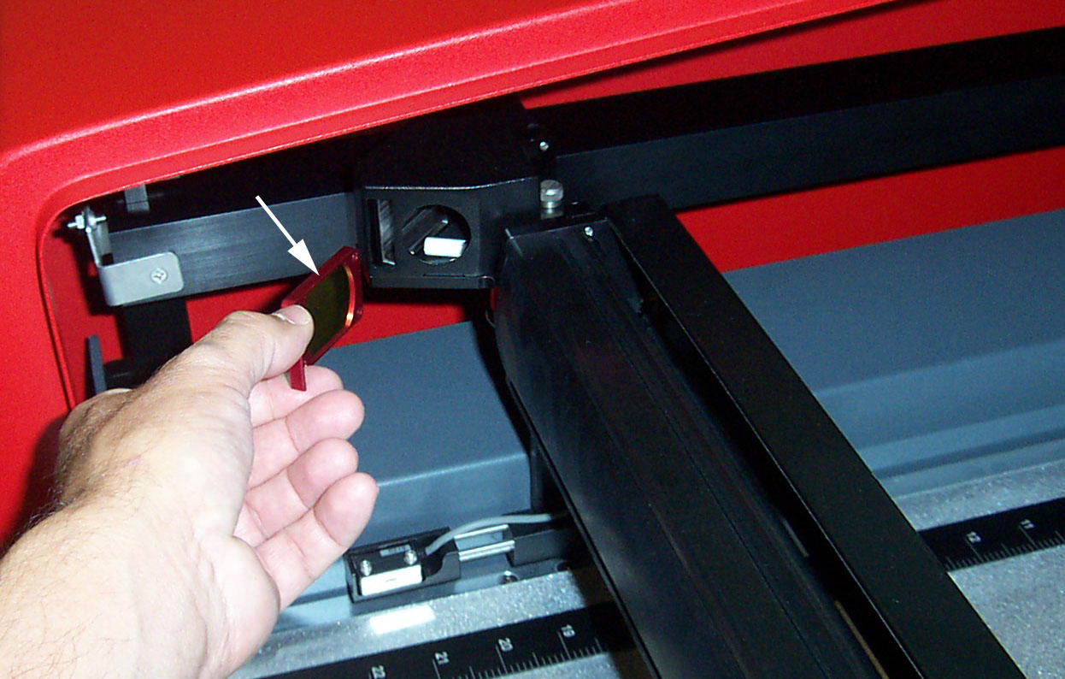
Locate the #2 Mirror Holder located on the left side of the X-rail. Grasp its protruding red handle with your thumb and forefinger and slide it out (Fig 1). Turn the #2 Mirror Holder over and inspect the optic for visual contamination. Clean as necessary. To re-insert the #2 Mirror Holder, slide it into the mounting slot until it stops.

Inspect the #2 mirror and clean it only if there is debris present. To clean the #2 mirror with a cotton swab, moisten the cotton swab with the lens cleaning solution supplied with the laser system. DO NOT use other types of cleaners or solutions.
Figure 1
Gently roll the cotton swab across the mirror once. DO NOT drag the swab or roll it back and forth as this can scratch the mirror. If the mirror did not come clean, use a fresh cotton swab and repeat the procedure. Do not be concerned about small pieces of lint that come off of the cotton swab. They will be vaporized as soon as the laser hits it. You can cause more damage to the mirror by trying to remove the lint than by leaving it alone.

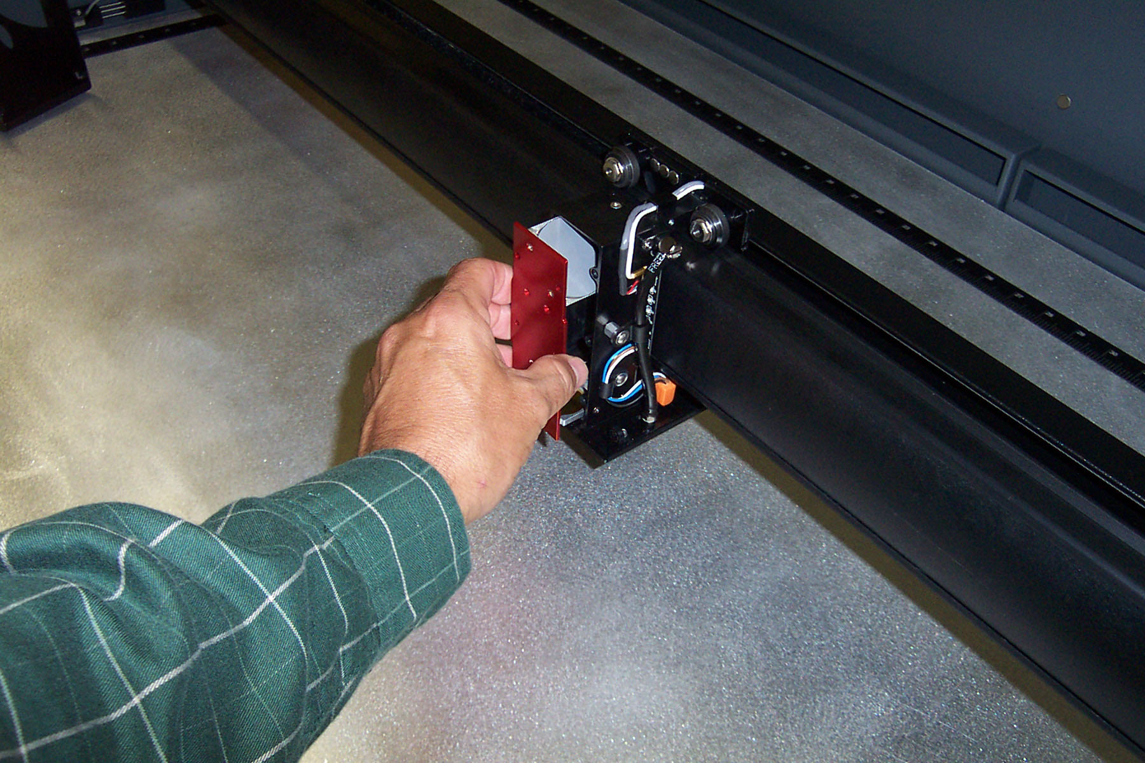
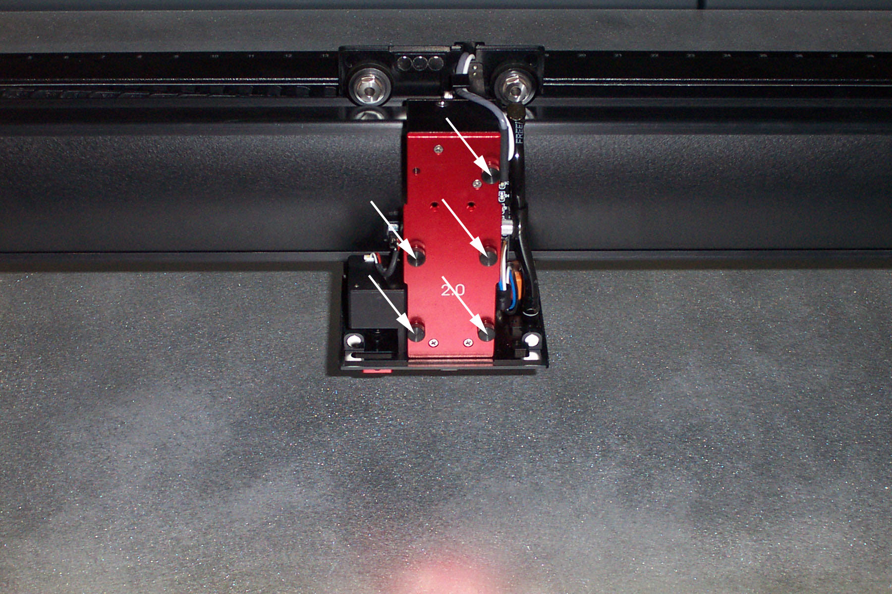
#3 Mirror and Focus Lens
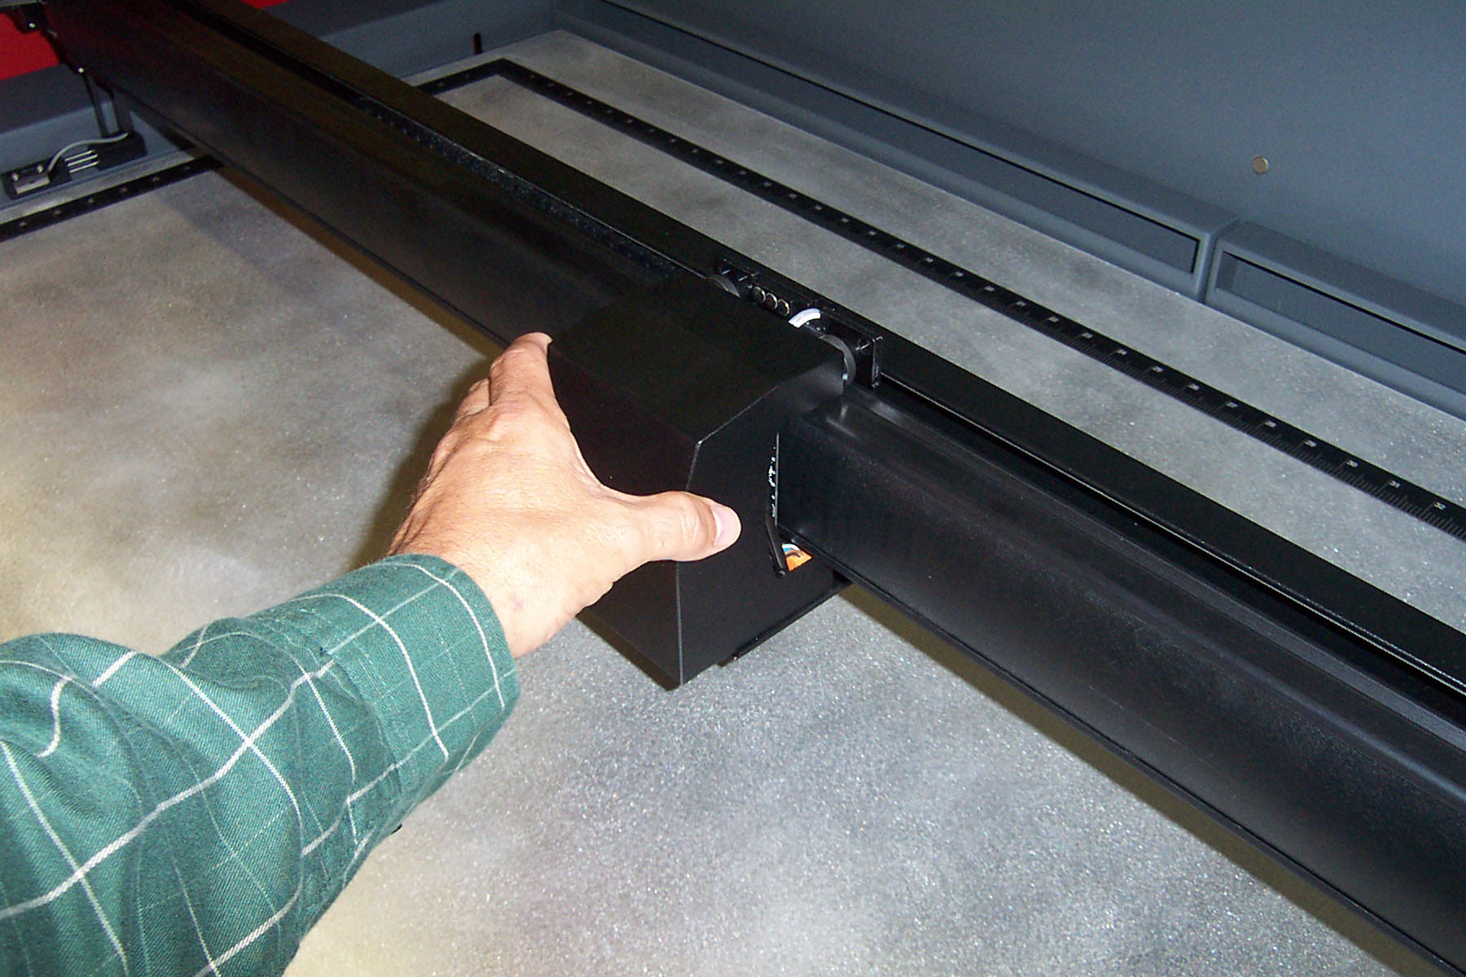
Figure 2 Figure 3 Figure 4
To gain access to the #3 mirror and the focus lens, remove the cover in by pulling the cover straight out (Fig 2). After cover has been removed the lens assembly kit will be exposed (Fig 3). Hold the cover with one hand, and remove the 5 thumbscrews with your other hand (Fig 3). Pull the front cover straight out (Fig 4). The #3 mirror and the focus lens are both mounted to the front cover.

Tilt the front cover enough to enable you to apply the lens cleaning solution directly to the #3 mirror and to the focus lens. Flood the reflective surface of the #3 mirror with the solution. If heavy debris is present, let the solution soak in for a minute. Roll a fresh cotton swab across the mirror in one direction. Use a fresh swab for each pass. Be gentle when cleaning the optic to avoid scratching the surface. Repeat this procedure for the focus lens but make sure you clean both sides of the lens.

Beam Window
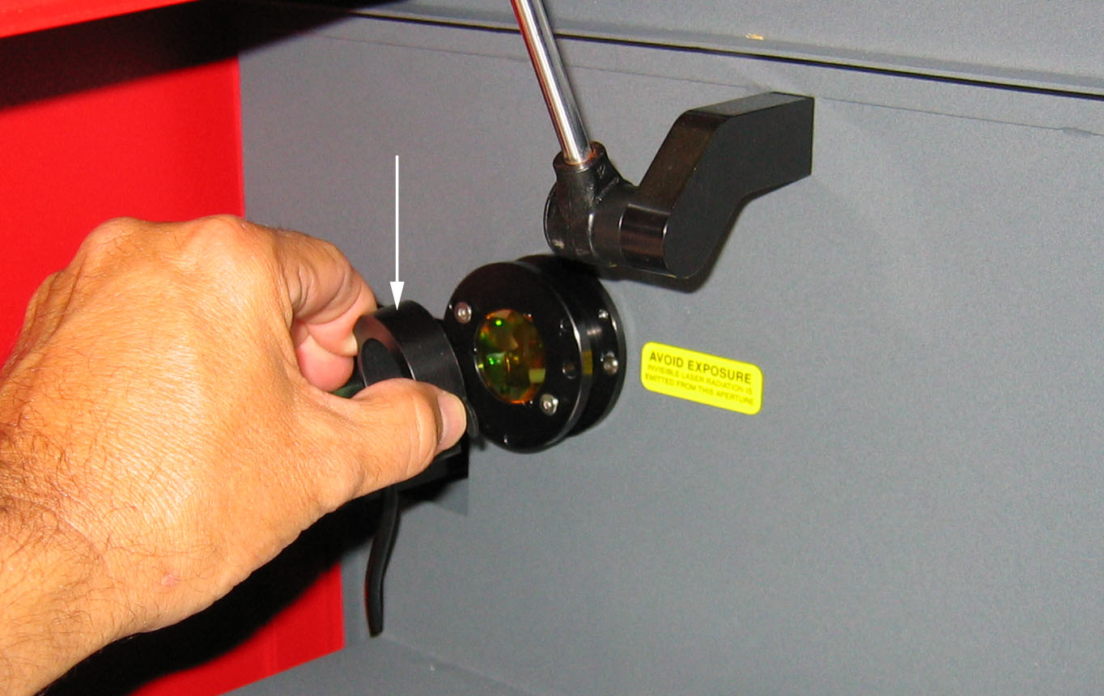
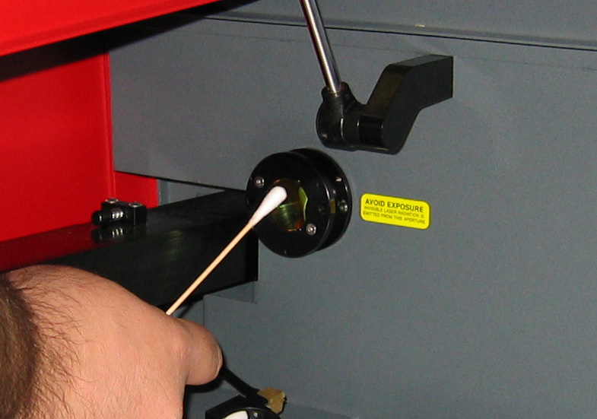

Figure 5 Figure 6
The Beam Window is where the laser beam enters into the engraving area. It is located in the upper left hand corner of the engraving area against the back wall and is yellow in color. It is only necessary to clean the front side of the beam window. Do not remove the optic to clean it; simply clean it in the same manner as the #2 mirror. To clean you must remove the beam window diffuser by slightly rotating CCW until diffuser is free (Fig 5). Using a Cotton Tipped Applicator and Lens Cleaner lightly wipe debris away from beam window (Fig 6).

Exhaust Plenum Cleaning
- Power system ON.
- Using the Z-axis controls, raise the Z-axis table as high as possible. Power the system OFF.
- Locate and remove the two button head screws (1) found on the back of the laser system.
- Open the front door. Using both hands, reach in and grab exhaust plenum. Lift the plenum straight up until the tabs (2) of the plenum clear the two flat head screws (3) they are resting on. Tilt the bottom of the plenum towards you and remove it from the system. Using your soap and water solution, clean the inside of plenum as well as the inside rear wall of the Laser System.
- Installation is opposite of removal. Make sure that the plenum tabs rest on the two flat head screws.

Adjustments and Lubrication
There are no periodic adjustments normally required. The Guide Wheels in the motion system will self adjust to take up any clearances as they begin to wear. The belts are fiber reinforced and will not stretch under normal use so that periodic tension adjustment is not necessary. Optical alignment is not necessary because the laser and the #2 mirror are fixed.

X Guide Wheels
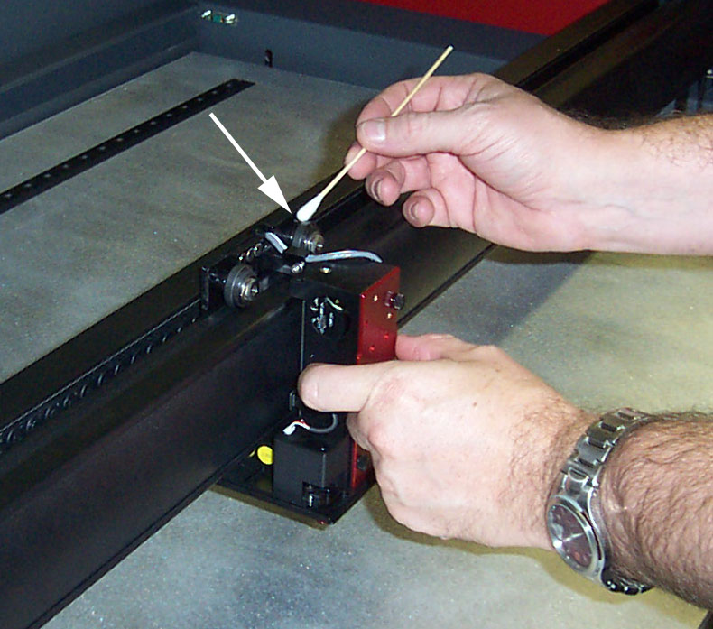
All wheels in the system are sealed and do not require lubrication. DO NOT lubricate the tracks that the wheels ride in. The X Axis Carriage has 4 wheels, 2 located on top and 2 underneath. Clean all 4 wheels (Fig 7) using a Cotton Tipped Applicator. Press the applicator against the wheel and slowly move the carriage until bearing makes at least 1 complete revolution. Repeat on the 3 remaining wheels.

Figure 7
Y Guide Wheels
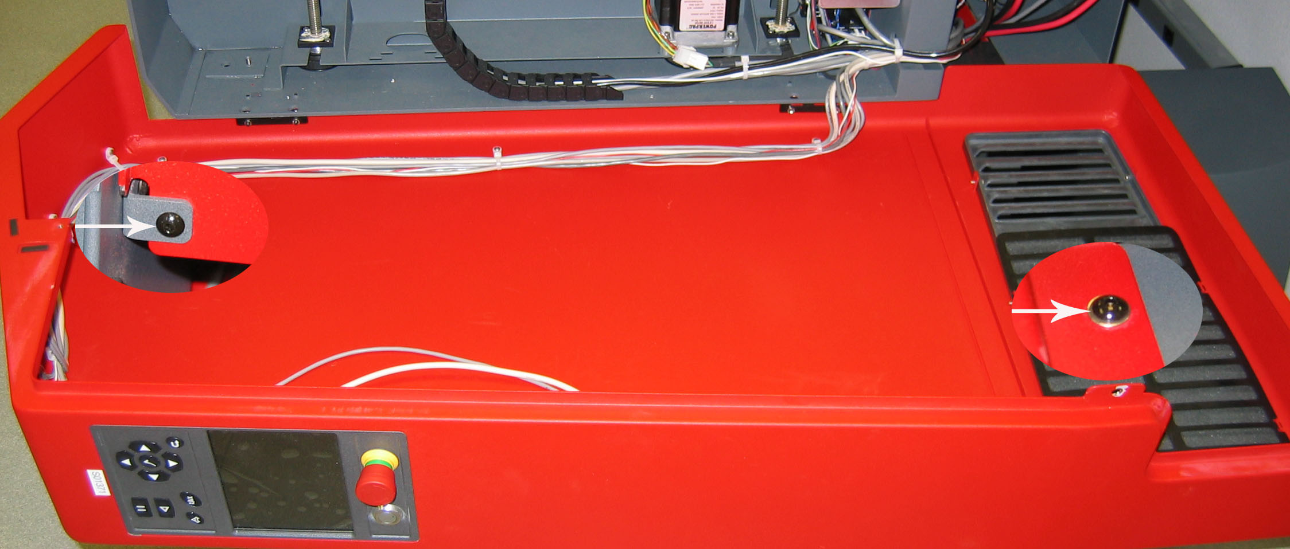
Figure 8
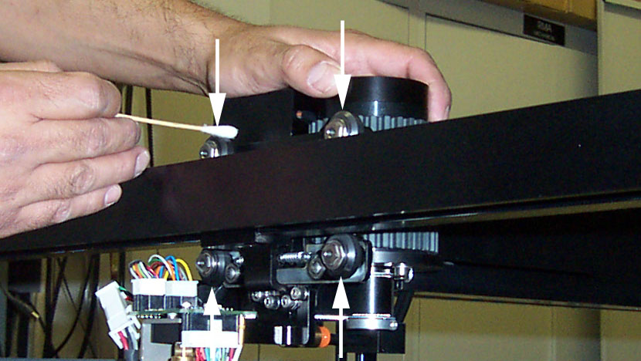
The Y Axis contains 4 wheels, 2 located on top of the right Y Axis Rail and 2 below. To properly clean the Y Axis wheels, you must lower the Right Side Panel. 1st lower the Rear Laser Cover by disengaging both latches. Locate and remove both front and rear 3/32” Button Head Screws (Fig 8). The Right Side Panel is mounted using hinges, slowly lower cover.
Press a Cotton Tip Applicator to the bearing a slowly move the arm from top to
Figure 9
bottom until wheel makes at least 1 complete revolution (Fig 9).

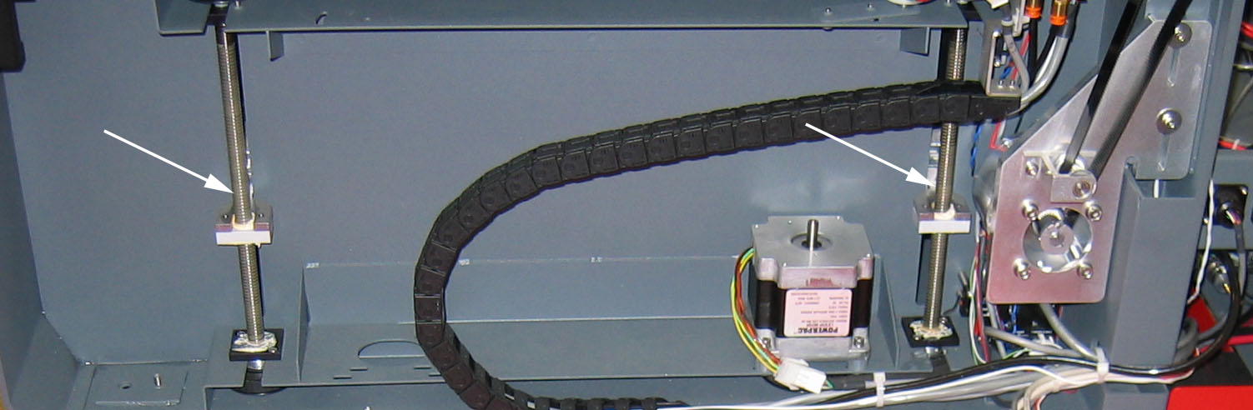
Figure 10
The only lubrication that may be required is the screw threads (Fig 10) for the table lifting mechanism. After some time, contaminants can adhere to the lubricant, which can cause the engraving table to bind up or sound squeaky. If this is the case, wipe off the contaminated grease with a soft cloth dampened with alcohol and apply fresh white lithium grease to the screw threads. NEVER SPRAY ANY DEGREASING SOLUTIONS DIRECTLY ONTO THE THREADS. Run the table up and down to work in the fresh grease. Repeat if necessary.

Maintenance Schedule
Since the maintenance requirements of the laser system is dependent on the type of material being run, the quantity of material being removed, the hours of operation, and the quality of the exhaust blower, it must be user defined.

As a starting point, we recommend the following schedule:

- As necessary
Engraving table
Main enclosure
Top door window

- Every 8 hours of engraving
Clean X-axis and Y-axis bearings
Clean X-axis and Y-axis rails and bearing tracks
Clean X-axis belt.
Check beam window, #2 mirror, #3 mirror, and focus lens for debris. Clean ONLY if dirty.

- Every month
Clean cooling fan filters
Clean and re-lubricate Z-axis lead screws
Check for X-axis and Y-axis belt wear – replace as necessary
Check and/or clean X-axis and Y-axis drive gears
Check for X-axis and Y-axis bearing wear – replace as necessary
Inspect system for loose screws and mechanical parts – tighten if necessary

- Every 6 months
Exhaust plenum

If you are noticing a considerable buildup of debris on the optics and the motion system, clean the system at more frequent intervals. If your system has remained relatively clean, you can extend your cleaning intervals. Keep in mind that a clean machine is a better performing machine and can extend the life of the parts as well as reduce the possibility of down time. If you have any questions about maintaining the laser system, please contact our Service Department.

